**STUDY GUIDE**

**BLOCK – I**

**Foundation – I & E Hematopoietic & Lymphoid Module**

**1st Year MBBS**

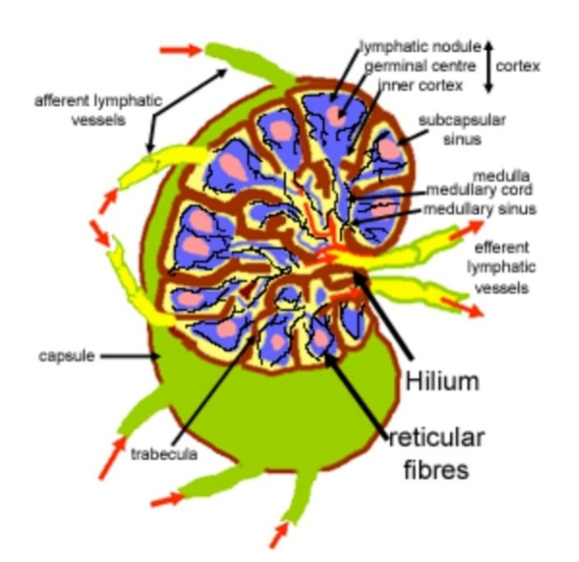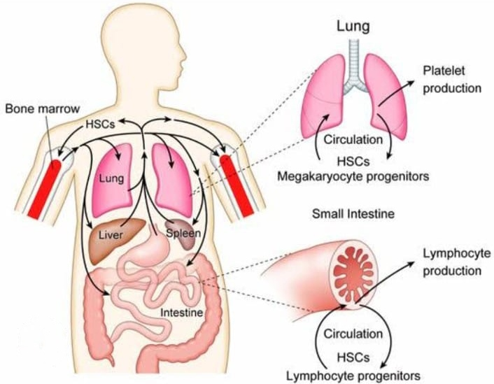

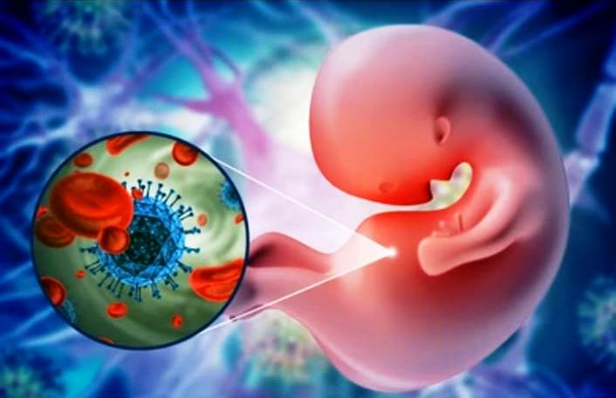



**Department Of Medical Education**

**D. G. KHAN MEDICAL COLLEGE D. G. KHAN**

# Table of Contents

Contents

Table of Contents 2

1. List of Abbreviations 4

2. Curriculum 2k24 Framework 7

3. Introduction to Study Guide 10

1. Communicating information on the organization and management of the module: 10

2. Defining the objectives expected to be achieved by the end of the module: 10

3. Identifying the learning strategies employed to achieve module objectives: 10

4. Providing a list of learning resources: 10

5. Highlighting information on the contribution of continuous assessment and semester examinations: 10

6. Including information on assessment methods: 10

7. Focusing on examination policies, rules, and regulations: 10

4. Block–1 Module Committee 10

5. Introduction of Foundation-I Module 12

5.1. Module Rationale 13

5.2. Module Outcomes 14

➢ Anatomy 15

5.3. Learning Objectives 15

5.3.1. Knowledge 15

5.3.2. Skills 36

6. Introduction of Hematopoietic and Lymphoid Module 41

6.1. Module Rationale 42

6.2. Module Outcomes 43

6.3. Learning Objectives 44

6.3.1. Knowledge 44

➢ Pathophysiology and Pharmacotherapeutics 49

6.3.2. Skills 51

7. Attitude 53

➢ Interactive Lectures 56

➢ Small group discussions 56

➢ Practical’s 56

➢ Clinical Skills Session 56

➢ Case based Learning 56

➢ Problem Based Learning 56

➢ Self-directed learning 56

9. Assessment Methodologies 57

1. Theory 57

• SEQ’s 57

2. Practical 57

• OSCE 57

3. OSVE 57

Statutes 58

First Professional Exam: 58

Second Professional Exam: 58

10. WrittenExamination 59

11. Oral/Practical/ClinicalExamination 60

Year 1 60

B. Block 2 (Musculoskeletal &Locomotion-1) 61

C. Block 3 (Cardiovascular-l +Respiratory-1) 61

13. No grace marks shall be allowed in any examination or practical under any guise or name. 62

11. Exam Regulations by UHS 63

12. Examination Rules DGKMC 66

13. Table of Specification (TOS) Error! Bookmark not defined.

14. Frame work of Block-1 Module Timetable2024 68

15. Learning Resources 70

# List of Abbreviations

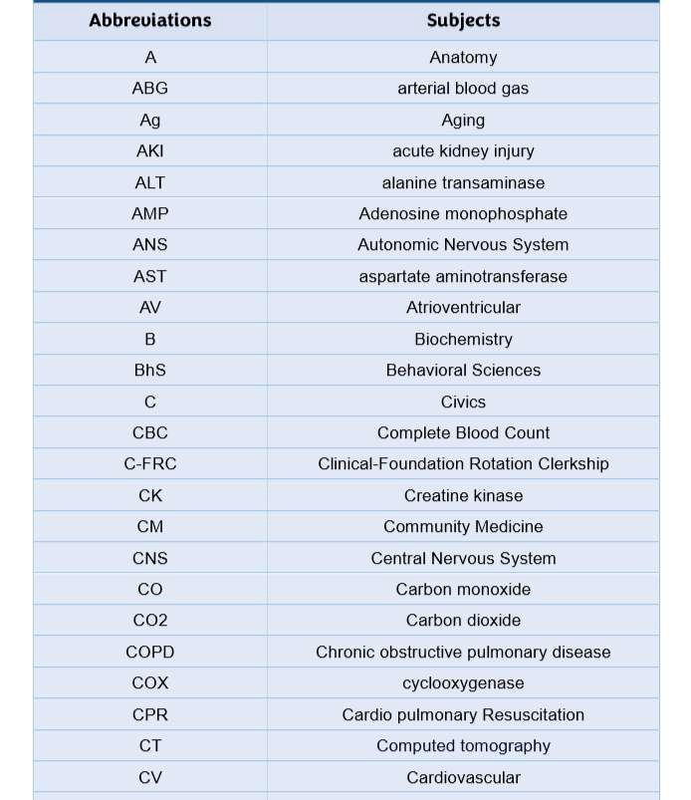

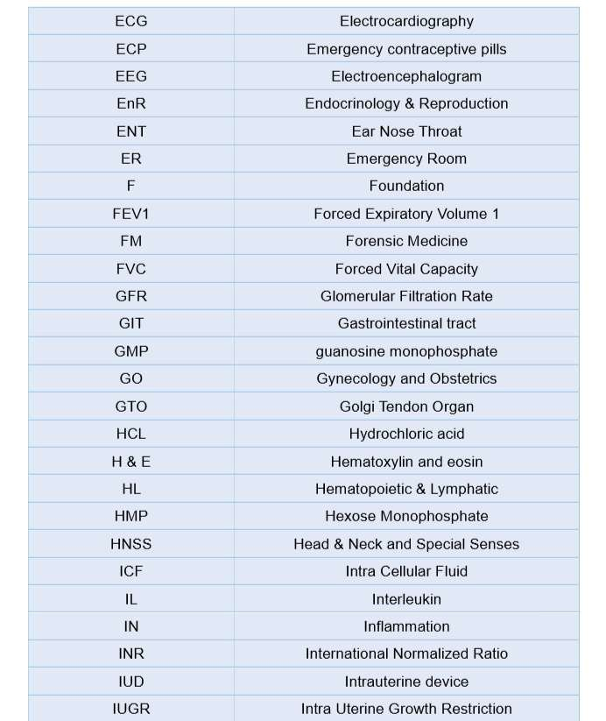

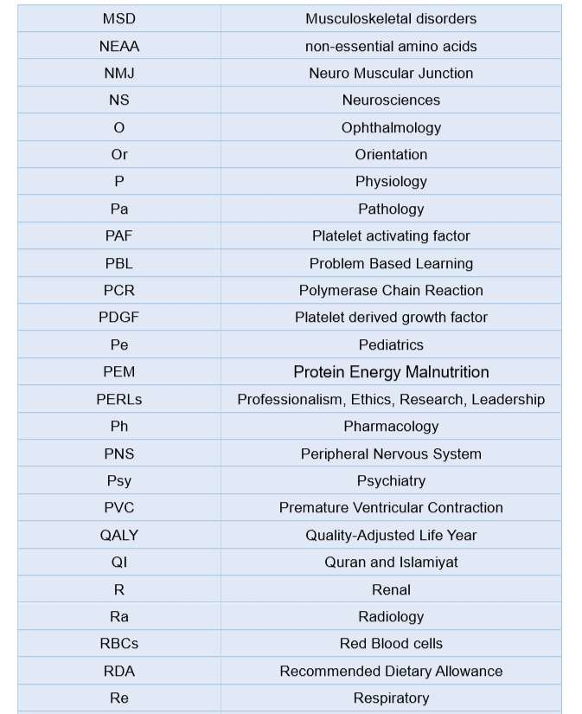

# Curriculum 2k24 Framework

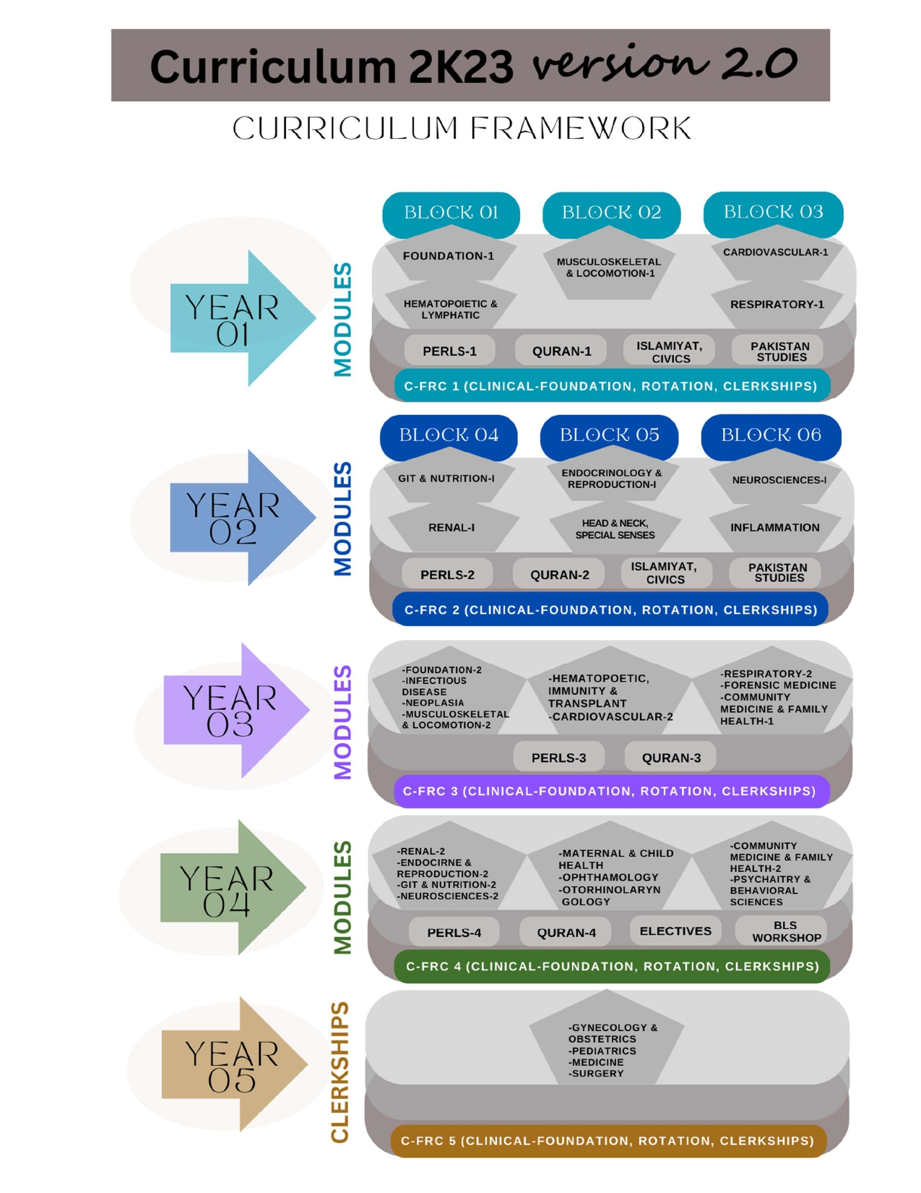

|  |  |  |  |
| --- | --- | --- | --- |
| Tentative Academic Calendar for 1st Year MBBS Session 2024-25 | | | |
| **Activity (Blocks, Exams, Holidays, Vacations** | **Dates** | **Week** | **Modules** |
| **Block 1 w.e.f. (03-03-2025 to 31-05-2025)** | | | |
| **Start of Block 1 on 03 March 2025** | **03-03-2025 to 08-03-2025** | 1 | **FOUNDATION I** |
|  | **10-03-2025 to 15-03-2025** | 2 |
|  | **17-03-2025 to 22-03-2025** | 3 |
| **Spring Vacations/ Eid-ul-Fitar Holidays (30-03-2025 to 01-04-2025)** | **24-03-2025 to 29-03-2025** | 4 |
| **31-03-2025 to 5-04-2025** | 5 |
|  | **07-04-2025 to 12-04-2025** | 6 |
|  | **14-04-2025 to 19-04-2025** | 7 |
|  | **21-04-2025 to 26-04-2025** | 8 |
| **Labour Day (01-05-2025)** | **28-04-2025 to 03-05-2025** | 9 |
|  | **05-05-2025 to 10-05-2025** | 10 |
|  | **12-05-2025 to 17-05-2025** | 11 | **HEMATOPOIETIC & LYMPHATIC** |
|  | **19-05-2025 to 24-05-2025** | 12 |
|  | **26-05-2025 to 31-05-2025** | 13 |
| **End of Block 1 on 31 May 2025** | **02-06-2025 to 07-06-2025** | 14 | **Block 1 Exam** |
| **Block 2 w.e.f. (02-06-2025 to 06-09-2025)** | | | |
| **Summer Vacations / Eid-ul-Adha (7 to 9 June 2025) / Ashura Holidays (5 & 6 July 2025)** | **08-06-2025 to 10-07-2025** | 15-18 | **Remedial/ Resit of Block 1 if needed** |
| **Start of Block 2** | **14-07-2025 to 19-07-2025** | 19 | **…..cont. MUSCULOSKELETAL & LOCOMOTION-1** |
|  | **21-07-2025 to 26-07-2025** | 20 |
|  | **28-07-2025 to 02-08-2025** | 21 |
|  | **04-08-2025 to 09-08-2025** | 22 |
| **Independence Day (14 August 2025)** | **11-08-2025 to 16-08-2025** | 23 |
|  | **18-08-2025 to 23-08-2025** | 24 |
|  | **25-08-2025 to 30-08-2025** | 25 |
| **End of Block 2 on 30 August 2025**  **Eid Milad-ul-Nabi (5 Sep, 2025)** | **01-09-2025 to 06-09-2025** | 26 | **Block 2 Exam** |
| **Remedial/ Resit of Block 2 will be conducted along with Block 3 if needed** | | | |
| **Block 3 w.e.f. (08-09-2025 to 29-11-2025)** | | | |
| **Start of Block 3 on 8 September 2025** | **08-09-2025 to 13-09-2025** | 27 | **CARDIOVASCULAR I** |
|  | **15-09-2025 to 20-09-2025** | 28 |
| **Students Week** | **22-09-2025 to 27-09-2025** | 29 |
|  | **29-09-2025 to 04-10-2025** | 30 |
|  | **06-10-2025 to 11-10-2025** | 31 |
|  | **13-10-2025 to 18-10-2025** | 32 |
|  | **20-10-2025 to 25-10-2025** | 33 |
|  | **27-10-2025 to 01-11-2025** | 34 | **Respiratory I** |
|  | **03-11-2025 to 08-11-2025** | 35 |
|  | **10-11-2025 to 15-11-2025** | 36 |
|  | **17-11-2025 to 22-11-2025** | 37 |
| **End of Block 3 on 22 November 2025** | **24-11-2025 to 29-11-2025** | 38 | **Block 3 Exam** |
| **Remedial/ Resit of Block 9 will be conducted during Prep leaves if needed** | | | |
| **Pre-Professional Exam Leaves** | | | |

|  |  |  |  |  |  |  |  |  |  |  |  |  |  |  |  |  |  |  |  |  |  |
| --- | --- | --- | --- | --- | --- | --- | --- | --- | --- | --- | --- | --- | --- | --- | --- | --- | --- | --- | --- | --- | --- |
| **Block 1 (11 Weeks)** | | | | | | | | | | | | | | | | | | | | | |
| **Module** | **Anatomy** | | |  | **Physiology** | | |  | **Biochemistry** | | |  | **Pathology** | | |  | **Pharmacology** | **Community Medicine** | **Behavioral Sciences** | **Aging** |
| **Theory** | **Pract.** | **Total** | **Theory** | **Pract.** | **Total** | **Theory** | **Pract.** | **Total** | **Theory** | **Pract.** | **Total** |
| **Foundation Module (8 Weeks)** | **48** | **22** | **70** | **40** | **12** | **52** | **36** | **9** | **45** | **12** | **2** | **14** |  | **4** | **8** | **8** | **1** |
| **Hematopoietic & Lymphatic (3 Weeks)** | **3** | **2** | **5** | **20** | **6** | **26** | **19** | **6** | **25** | **5** | **-** | **5** | **2** | **3+2= 5** | | **1** |
| **Total** | **51** | **24** | **75** | **60** | **18** | **78** | **55** | **15** | **70** | **17** | **2** | **19** | **6** | **11** | **10** | **2** |

# Distribution Of Total Contact Hours In Block 1

8

# Introduction to Study Guide

The study guide serves several crucial purposes:

### Communicating information on the organization and management of the module:

This aids students in identifying the appropriate point of contact in case they encounter any difficulties during the semester.

### Defining the objectives expected to be achieved by the end of the module:

It outlines clear learning goals, ensuring that students understand what is expected of them academically.

### Identifying the learning strategies employed to achieve module objectives:

These strategies may encompass various methods such as lectures, small group sessions, clinical skills practice, demonstrations, tutorials, and case-based learning.

### Providing a list of learning resources:

Students are offered a comprehensive list of resources, including books, computer-assisted learning programs, web links, and journals. These resources empower students to maximize their learning potential.

### Highlighting information on the contribution of continuous assessment and semester examinations:

This section emphasizes the significance of ongoing assessments and final exams in determining a student's overall performance in the module.

### Including information on assessment methods:

Details about the various assessment methods employed to evaluate students' progress in achieving the objectives are outlined.

### Focusing on examination policies, rules, and regulations:

This section clarifies the policies and regulations governing examinations, ensuring that students are well-informed about the rules they must adhere to during their assessments.

By providing students with this comprehensive guide, educational institutions aim to enhance their learning experience, facilitate effective academic management, and foster compliance with academic standards and regulations.

10

# Block–1 Module Committee

|  |  |
| --- | --- |
| BASIC HEALTH SCIENCES | CLINICAL SCIENCES |
| *Anatomy:*  Dr. Hamd Binte Syed | *Cardiology:*  Dr. Majid Bashir |
| *Physiology:*  Prof. Abdul Rehman Khokar | *Medicine:*  Dr. Faizan Mustafa |
| *Biochemistry:*  Dr. Farooq Ahmad | *Peads:*  Dr. Sher Khoh |
| *Pathology:*  Prof. Shahid Habib | *Radiology:*  Dr. Faiza |
| *Pharmacology:*  Prof. Abdul Jabbar | *Surgery:*  Dr. Rizwan Anwar |
| *Community Medicine:*  Dr. Moazzam Ali Jaskani | *RESEARCH & SKILLS DEVELOPMENT CENTER* |
| *Behavioral Sciences:*  Dr. Sadia |  |
| *Department of Medical Education:*   * Prof. Haq Dad Durrani (Director) * Dr. Munnaza Batool (PWMO) * Dr. Amar Hussain Khan (Senior Demonstrator) * Dr. Shamsa Kanwal (Demontrator) | |
| *Principal D. G. Khan Medical College:*  Prof. Asif Ali Qureshi | |
| *STUDY GUIDE COMPILED BY: Department of Medical Education* | |



12

# Introduction of Foundation-I Module

Welcome to the Foundations module, where we embark on a journey deep into the intricacies of life processes within the human body. At its core, our exploration begins with the remarkable cell, the fundamental unit of life. Understanding its structure lays the groundwork for comprehending how cells communicate and transport essential substances, maintaining a delicate balance within the body known as homeostasis. This balance extends to the chemical reactions that drive cellular processes, ensuring optimal function and health.

As we delve further, we uncover the vital role of blood in maintaining homeostasis, acting as a conduit for nutrients, oxygen, and immune defense. This intricate network of circulation is intimately linked with the autonomic nervous system, which regulates involuntary processes such as heart rate and digestion, seamlessly integrating with the body's movement.

Indeed, movement is a symphony orchestrated by muscles, each contraction and relaxation finely tuned to enable mobility and support bodily functions. These muscles, governed by the autonomic nervous system, adapt and grow throughout life, reflecting the ongoing process of growth and development.

From the earliest stages of embryogenesis to the complexities of adulthood, the human body undergoes a remarkable journey marked by growth and change. Genetics, nutrition, and environmental factors intricately influence this journey, shaping the individual from infancy to old age.

In conclusion, our exploration of these interconnected themes provides a holistic understanding of human biology, underscoring the intricate web of relationships that govern life processes. By mastering these foundational concepts, we not only gain insight into the mechanisms of health and disease but also cultivate the skills necessary for clinical practice. Welcome to the beginning of your journey in the noble pursuit of healing and improving the lives of others.

# Module Rationale

Tomorrow’s doctor is required to acquire competencies, which could align his knowledge base and skill set for his professional practices. The foundation of knowledge needs to commence from 'The Cell'. The cell is a structural and functional unit of life and has a role in normal homeostasis ensuring appropriate cellular functions. Hence, this module has been designed to introduce a blend of molecular, genetic, anatomical, physiological, and psychosocial information essential for developing a perspective on the function of the human body in health and disease. Besides, an initial orientation to pharmacology and pathology subject has been provided so that students are able to use this information in the coming modules.

# Module Outcomes

1. Describe the microscopic features of nerve cells, muscle cells, general features of epithelia of the body.
2. Appraise the functional characteristics of various components of cell membrane and organelles of cell.
3. Differentiate between the dynamics of various transport mechanisms along the cell membrane.
4. Compare the functional differences between RBCs, WBCs and blood groups.
5. Explain the significance of homeostatic mechanisms in keeping body's internal environment nearly constant.
6. Appraise the formation and functions of autonomic nervous system.
7. Correlate the structural design of each organ to its function.
8. Acquire information about the different fascial planes in the different regions of the body & their surgical importance.
9. Use descriptive anatomical terms of position to describe the different body structures in relation to each other.
10. Describe the movements of body using proper anatomical terms of movement.
11. Describe and demonstrate the various bony land marks.
12. Describe the types of joints and correlate them to the mechanisms of movement.
13. Classify the bone, joints and muscles based on the structure, function, and phylogenetic origin.
14. Describe the structures associated with muscles and explain their functional correlations.
15. Classify and describe the cardiovascular system and correlate it functionally.
16. Amplify the anatomical basis for radiological, cross-sectional, and surface anatomy.
17. Correlate clinicopathologically the apoptosis in health &diseases.

## Anatomy

# Learning Objectives

## Knowledge

|  |  |  |
| --- | --- | --- |
| **Topic** | **Sub Topic** | **Learning objectives** |
| **Gross Anatomy** | Introduction to General Anatomy | * Briefly describe the applied branches of anatomy * Describe the "Anatomical Position" Describe the anatomical planes of body. * Describe the terms of relationship, commonly used in Anatomy. Describe the anatomical terms used specifically for Limbs. Describe the terms related to movements |
| Bones (Osteology) | * Describe, identify, and exemplify the general morphological features of bones. * Describe the developmental classification of bones. * Describe the regional classification of bones. * Describe the morphological classification of bones. * Describe and exemplify Sesamoid, Pneumatic, Wormian and Hetero topic bones. * Describe the classification of bones on the basis of osteogenesis. * Describe the relationship of growing end of bones with the direction of nutrient foramen * Describe the blood supply, innervation and lymphatic drainage of various types of bones * Describe the use of bone tissue for bone marrow biopsy and bone grafting. * Describe the salient features of common types of fractures and basic concept of healing of fracture. |
| Cartilage (Chondrology) | * Describe the general features of cartilage and its importance in gross anatomy. * Describe the subtypes and gross features of Hyaline Cartilage * Describe the gross features of Elastic Cartilage * Differentiate the three types of cartilages |
| * Describe and exemplify the structural classification of Joints(synovial, |

|  |  |  |
| --- | --- | --- |
|  | Joints (Anthology) | Cartilaginous & fibrous) along with their sub- classification.   * Describe the components and characteristic features of a Synovial Joint Describe the blood supply, innervation and lymphatic drainage of Synovial Joints, cartilaginous joints, and fibrous joints. * List the factors stabilizing a synovial joint. * Define common joint injuries and diseases |
| Integumentary System | * Describe the structure and function of Skin on the basis of its two layers; Epidermis and Dermis * Describe the structure of Hair as an appendage of skin. * Describe the structure of Nail as an appendage of skin. * Describe the structure of Sweat and Sebaceous Glands * Describe the structure and function of Superficial Fascia * Describe the structure, function, and modifications of Deep Fascia * Describe important clinical correlates of skin (skin infections, sebaceous cyst, skin burns and skin grafting) |
| Muscle Tissue (Myology) | * Classify and describe Muscle Tissue based on Structure, Function and Development * Describe Somatic and Visceral Muscles * Describe and differentiate the Red and White Variety of Skeletal Muscles * Classify and describe the skeletal muscles based on architecture. * Classify skeletal muscle based on action. * Describe the parts of a skeletal muscle. * Describe and differentiate the basic organization of innervation to skeletal, smooth, and cardiac muscle. * Describe the structure of Synovial Bursae * Comprehend the meaning of Hypertrophy, * Hemiplegia, quadriplegia, paraplegia, hemiparesis |
|  | * Classify the types of blood circulation. * Classify and exemplify various types of blood |

|  |  |  |
| --- | --- | --- |
|  | Vascular System (Angiology) | Vessels.   * Describe and exemplify various types of anastomoses. * Explain the importance of End Arteries * Describe the general organization of Lymphatic Circulation * Define the terms: Lymphoid Tissue, Tissue Fluid, Lymphatic Capillaries, Lymph and Lymphatic Vessels * Define the terms; Lymphangitis, Lymph adenitis, Lymphadenopathy |
| Nervous Tissue (Neurology) | * Define neuron. * Describe the anatomical structure of aneuron. * Classify neurons based on morphology with examples. * Classify neurons based onfunction. * Describe the components of the central nervoussystem. * Describe the components of the peripheral nervoussystem. * Name the supporting cells (neuroglia) of the central nervoussystem. * Describe the structure and functions of the neuroglia of the central nervoussystem. * Enumerate the supporting cells (neuroglia) of the peripheral nervoussystem. * Describe the structure and functions of the neuroglia of the peripheral nervoussystem. * Enlist the cranial nerves I to XII * Describe the types of nerve fibers carried by and distribution of the cranialnerves. * Describe the formation, types of modalities carried by, and distribution of the spinal nerves. * Define and explain Dermatome(s) * Define and explain Myotome(s) * Describe the formation ofPlexuses. * Differentiate between Somatic and Visceral nervoussystem. * Define Receptors Describe the functions of receptors. * Classify sensory receptors based on modality (withlocation) * DefineEffectors * Describe the functions ofeffectors. |

|  |  |  |
| --- | --- | --- |
|  |  | * Describe ANS and differentiate between sympathetic and parasympathetic nervous system |
|  | Imaging in Anatomy | * Identify displacement of fracture segmentsof the bone Identify dislocation ofjoints |
| **Embryology & Post-Natal Development** | Cell division and Chromosomal Abnormalities | * Define Chromosome Theory ofinheritance * Enlist different stages of Mitosis andMeiosis * Compare and contrast mitosis andMeiosis * Enlist the numerical chromosomalanomalies * Describe the anatomical basis for numerical chromosomalabnormalities * Describe the clinical presentation of numerical chromosomal abnormalities and justify themEmbryologically * Describe the clinical presentation ofstructural chromosomal abnormalities and justify them Embryologically * Describe the embryological basis for mosaicism * Describe the embryological basis forteratoma * Describe Concept of Gene Mutation. Enlist common diagnostic techniques for identifying geneticabnormalities. |
| Gametogenesis Spermatogenesis | * Describe the Process of spermatogenesisand spermiogenesis * Describe the embryological basis for Abnormalgametes |
| Gametogenesis and Oogenesis | * Describe the Prenatal and postnatal maturation ofoocyte |
| Oogenesis | * Describe the significance of arrested development ofoocyte |
| Gametogenesis | * Compare and contrast oogenesis and spermatogenesis |
| Female Reproductive Cycle | * Describe the hormonal control of female reproductive cycles * Enumerate and describe the steps of the ovariancycle * Describe the process ofovulation * Describe the formation, function and fate of corpusluteum * Define Mittelschmerzpain * Define menstrualcycle * Describe the phases of menstrualcycle |
| Transportation of | * Describe the transportation ofOocyte |

|  |  |  |
| --- | --- | --- |
|  | gametes |  |
| Fertilization | * Describe Capacitation and Acrosomal Reaction * Definefertilization * Describe the phases offertilization * Draw and label a diagram illustrating the phases offertilization * Enumerate and describe the results of fertilization |
| Contraception | * Definecontraception * Explain the mechanisms of following contraceptivetechniques: * Barriermethods * Hormonalmethods * Intrauterine device(IUD) * Emergency contraceptivepills * (ECPs) * Male and femalesterilization |
| Infertility & assisted Reproductive techniques | * Describe the anatomical and physiological basis of male and femaleinfertility * Define assisted reproductivetechniques * Describe the mechanisms of following reproductivetechniques:   oIn vitro fertilization (IVF) and embryo transfer   * Explain the correlation of multiple births with assisted reproductivetechniques |
| Cleavage, blastocyst formation | * Describe the process of cleavage of embryo and blastocystformation * Describe the origin and uses of embryonic stem cells and the techniques of obtaining these cells from the embryo (reproductive cloning & therapeuticcloning) * Explain the embryological basis of spontaneousabortion * Compare and contrast thevilli * Describe the process ofCompaction * Describe the Formation of morula (division into inner and outer cellmass) |
| Implantation Week 2 of Development | * Describe the Uterus at the time of implantation (deciduareaction) * Illustrate the concept ofImplantation * Describe the Abnormal implantation/ extra uterineimplantations * Define the Molarpregnancy. |

|  |  |  |
| --- | --- | --- |
|  |  | * Describe the formation of amniotic cavity, embryonic disc, and umbilicalvesicle * Describe the formation of chorionicsac. |
| Utero-placental circulation | * Describe the Establishment of utero-placental circulation |
| Gastrulation | * Describe the Formation & fate of primitive streak * Draw a concept map highlighting the sequence of events responsible for transformation of bilaminar germ disc into trilaminar germdisc * Describe the embryology behind sacrococcygeal teratoma and justify its clinicalpicture * Describe the molecular factors responsible for gastrulation |
| Formation of notochord | * Describe the Invagination and movement of prenotochordalcells * Describe the Notochordal plateformation * Describe the Neuroenteric canalformation * Describe the fate of thenotochord * Describe the Establishment of bodyaxis * Draw and label the fate mapestablishment * Describe the Fate mapestablishment * Describe the molecular basis for notochord formation * Describe the role of notochord as aninducer * Describe the embryological basis for situs inversus Sirenomelia,holoprosencephaly * Describe the development of trophoblastand   chorionic villi during 3rd week of development |
| Derivatives of ectoderm | * Describe the Formation of neural tube from neuralplate. * Justify embryologically the clinical picture seen in various neural tubedefects * Describe the process of Migration of neural crestcells * Enlist the Derivatives of neural tube and describe the fate ofeach * Enlist the Derivatives of neural crest cells Enlist the ectodermalderivatives * Describe the molecular and genetic factors for the process ofneurulation * Describe important Neural tubedefects |

|  |  |  |
| --- | --- | --- |
|  | Mesodermal derivatives | * Describe the Differentiation of mesoderm into its constitutingcomponents * Describe the Somite formation and itsfate * Describe the Estimation of age bysomites * Describe the formation of intra-embryonic coelom |
| Early development of CVS | * Describe the processes of vasculogenesis&angiogenesis * Explain the features of primordial cardiovascularsystem * Describe the anatomical justification for Capillaryhemangiomas |
| Folding of Embryo | * Describe the Cephalo-caudalfolding * Describe the Lateralfolding |
| Germ layer derivatives | * Enlist the derivatives of germlayers * Enlist and Describe the Derivatives of intermediate and lateral plate mesoderm Enlist & Describe the Derivatives of endoderm * Enlist & describe the derivatives ofectoderm |
| Control of the embryonic  development | * Describe the Regulation of embryonic development by HomeoBoxgenes |
| Folding of Embryo Embryonic period | * Enlist the characteristic features of the embryo during 2ndmonth. * Describe the criteria for estimating the developmental staging in humanembryos * Explain the estimation of gestational &embryonicage |
| Fetal period | * Explain the measurement and characteristics of fetus/Key events during EmbryonicPeriod. * Describe the Overview of External appearance of fetus during fetal period. Enlist developmental horizons during fetal life event. * Describe Viability of fetuses and low birth weightbabies * Explain the factors influencing fetalgrowth * Describe the clinicalproblems   encountered by babies born with IUGR (Intra Uterine Growth Restriction) |
| Fetal Status | * Tabulate the criteria for estimating fertilization age during the fetalperiod * Describe the procedures for assessing fetal status |

|  |  |  |
| --- | --- | --- |
|  |  | * Describe the clinical picture of IUGR &factors resulting in IUGR (Intra Uterine GrowthRestriction) * DefinePre-eclampsia |
| Placenta | * List the fetalmembranes * Describe the macroscopic & microscopic features ofDecidua * Enlist the various parts of decidua Functionally correlate the parts of the decidua with itsstructure * Describe the Changes in the trophoblast leading to the development ofplacenta * Describe the Structure (macroscopic & microscopic) ofplacenta * Enlist & correlate the Functions of placenta with itsstructure * Describe the Microscopic anatomy of Placentalmembrane * Describe the Placental circulation (fetal & maternal) * Embryologically justify the hemolytic disease of theneonate * Describe the functions ofplacenta |
| Fetal membranes | * Describe the Formation & fate of Umbilical cord * Describe the Cord abnormalities Justify embryologically the clinical features observed in Absence of umbilical artery * Describe the formation and circulation of Amniotic fluid Enlist the components of amnioticfluid * Describe the Procedure of diagnostic amniocentesis * Explain the significance of amnioticfluid * Describe the consequences of oligohydramnios and polyhydramnios Define AmnioticBands * Explain the formation and fate of umbilical vesicle (yolk sac) Define Physiological UmbilicalHernia |
| Multiple pregnancies | * Describe the development of Dizygotictwins * Describe the development of Monozygotic twins * Describe the fetal membranes in twin pregnancy |

|  |  |  |
| --- | --- | --- |
|  |  | * Describe FetusPapyraceous * Explain the zygosity of thetwins * Describe the characteristics of various types of conjoined monozygotictwins |
| Prenatal diagnosis and fetal therapy | * Define pretermBirth * Describe parturition & three stages ofLabor. * Describe the Various methods of prenatal diagnosis * Describe the Fetaltherapy * Describe Maternal serumScreening * Corelate levels of Alpha feto protein levels and fetalAnomalies * Describe stem cell transplantation and gene therapy |
| Molecular regulations and signaling pathways | * Define morphogens, protein kinases, notch delta pathway, transcription factors, epigenetics |
| Teratogenicity | * Define teratology and causes of birthdefects * Define genomicimprinting * Define human disorders associated with geneticmutations * Describe birth defects caused by genetic factors: * numerical and structuralanomalies * Define and enlist theteratogens * Describe the role of following in causing teratogenicity   in humans:   * 1. Drugs   2. Environmentalagents   3. Chemicals & heavymetals   4. Infectiousagents   5. Radiation   6. Hormones   7. Maternaldiseases * Describe the basis for male-mediated teratogens * Describe prevention of birthdefects |
| Microscopic Anatomy (Histology & Pathology) | Introduction to microscopy &  staining techniques | * Describe different types ofmicroscopies * Describe Staining methods and their significance |
|  | * Describe the electron microscopic structure and fluid mosaic model of plasmamembrane |

|  |  |  |
| --- | --- | --- |
|  | Cell membrane | * Draw the fluid mosaic model of plasma membrane * Describe the structure of glycocalyx coat and lipid raft and correlate it withfunction * Describe different types of membrane proteins and theirfunctions * Explain different modes of transport across the cellmembrane |
| Cell organelles | * List the membranous and non-membranous cellularorganelles * Describe the structure of the following cellular organelles and correlate with their function:   Ribosomes  Endoplasmic reticulum (rough & smooth)  Golgi apparatus Lysosomes Proteasomes Mitochondria Peroxisomes   * Describe the structural components of cytoskeleton, and correlate them with their functions * Explain the histological basis of immotile ciliasyndrome * Describe the histological features of cytoplasmicinclusions * Describe the structure of nuclear envelope and nuclearpores |
| Cell nucleus | * Describe the structure ofchromatin * Describe the structure ofchromosome * Draw and label the structure ofnucleolus * Describe the structure ofnucleolus * Describe the structure and types of DNA andRNA * Describe the histological basis for apoptosis andnecrosis * Describe structure of different types of cell junctions * Describe the cell cycle & celldivision * Define important clinicopathological terms: Atresia, Hypertrophy, Atrophy,Hyperplasia, Metaplasia, Anaplasia, Neoplasia, Inflammation, Metastasis |

|  |  |  |
| --- | --- | --- |
|  | Epithelium | * Describe the histological structure and function of basement membrane (light and electron) * Draw and label a diagram illustrating the electron microscopic structure of basement membrane * Describe the basal surface modifications of epithelia * Describe the electron microscopic structure and functions of intercellular junctions (lateral surface modifications) and give their locations * Describe the Biochemical composition of the basolateralmodifications * Describe the electron microscopic structure &functions of the following apical cell surface specializations:   1. Microvilli   2. Stereocilia   3. Cilia * Classify and exemplify the epitheliawith their histological structure, locations and functions * Describe the structure of exocrineglands * Explain the mechanism of transport across the epithelia * Describe the classification ofexocrine glands on the basisof:   Shape of secretory portions and ducts Mode of secretion  Type of secretion |
| Connective tissue | * Describe the composition and list the constituents of connectivetissue * Classify the connective tissue withexamples * Describe the composition of ground substance of connectivetissue * Describe the composition, distribution, and function of glycosaminoglycans inconnective tissue * Describe connective tissue fibers,cells. Define Fibrosis * Describe the structure, distribution, and functions of the cells of macrophage- mononuclear phagocytic system * Describe the role of macrophages ininnate |

|  |  |  |
| --- | --- | --- |
|  |  | immunity & formation of foreign body Giant cell   * Describe the structure & functions of Mast cells. Role of Mast cells in immediate hypersensitivityreactions. * Describe structure of Plasma cells and their role in antibodyformation. * Describe the types of adipose tissue (white &brown), their histogenesis, locations and function * Describe lipid storage and mobilization in and from adipocytes and compare the brownand   white adipose tissue |

* **Physiology**

|  |  |  |
| --- | --- | --- |
| **Topic** | **Sub Topic** | **Learning objectives** |
| **Medical Physiology** | Cell Biology | * DefineHomeostasis * Explain control system of body by giving examples * Differentiate between Extracellular and IntracellularFluids * Explain the positive and negative feedback mechanisms withexamples * Explain the significance of feed forward/ adaptive control/delayed negative feedback mechanisms * Explain the structure of cellmembrane * Enlist the types of cell membraneproteins * Enumerate the functions of membrane proteins * Define and enumerate the functions of cell Glycocalyx * Enlist membranous and non-membranous organelles * Enlist the self-replicativeorganelles * Differentiate between the functions of smooth and rough endoplasmicreticulum * Explain the functions of Golgiapparatus * Enlist the enzymes oflysosomes * Explain the functions oflysosomes * Enlist the enzymes ofperoxisomes * Explain the functions ofperoxisomes * Enumerate the components and functions of cytoskeleton * Define and enlist types ofendocytosis * Explain the mechanism ofpinocytosis * Classify different transportmechanisms * Compare the composition of Na, K and Cl in extracellular and intracellularfluid * Define and enlist different types ofdiffusion * Explain the process of facilitated diffusion with the aid ofdiagram * Define and classify different types of active transport * Describe primary and secondary active transport withexamples * Explain voltage and ligand gatedchannels |

|  |  |  |
| --- | --- | --- |
|  |  | with examples Name Na, K channel Blockers.   * Discuss functions and significance of Na/K ATPasepump. |
| Blood | * Enumerate the functions ofblood * Explain the composition ofblood * Enumerate the plasmaproteins * Discuss functions of plasma proteins &describe the pathophysiology ofedema |
| Red Blood Cells | * Discuss the characteristics of red bloodcells * Explain different types of Bonemarrows * Enumerate the different sites oferythropoiesis at differentages * Explain the stages oferythropoiesis * Enumerate factors that regulateerythropoiesis * Discuss the site and role of erythropoietin in red blood cellproduction * Explain the significance of vitamin B12 and folic acid in maturation of red bloodcell |
| Hemoglobin | * Enumerate the types of normal hemoglobinin different ages oflife * Explain the role of Iron in Hemoglobin formation. * Define blood indices, give their normalvalues & enumerate the conditions in which these values aredisturbed * Enlist the abnormal types ofhemoglobin |
| White Blood Cells | * Enumerate the types of white bloodcells * Describe the characteristics and functions of Neutrophils * Explain the process of defenseagainst invading agent byneutrophils * Define leukocytosis andleukemia * Explain the effects of leukemia onbody * Defineleukopenia * Explain the process of defenseagainst invading agent bymacrophages * Discuss different lines of defense during inflammation * Explain the functions of neutrophils and macrophages in spread of inflammation (walling offeffect) * Define the Reticuloendothelialsystem * Enlist the different components of Reticuloendothelialsystem * Explain the characteristics and functionsof |

|  |  |  |
| --- | --- | --- |
|  |  | basophils   * Explain the characteristics and functions of eosinophils and enlist conditions in which these cells areraised |
| Blood Types | * Enumerate different blood grouptypes. * Explain the basis of ABO and Rh blood system * Explain the Landsteinerlaw |
| Autonomic nervous system | * Discuss Components of Autonomic nervous system * Explain the physiological anatomy of sympathetic and parasympathetic nervous system * Describe the types of adrenergic and cholinergic receptors and theirfunctions * Explain the effects of sympathetic and parasympathetic on variousorgans |

* **Medical Biochemistry**

|  |  |  |
| --- | --- | --- |
| **Topic** | **Sub Topic** | **Learning objectives** |
| **Medical Biochemistry** | Structure of cell | * Differentiate between different types ofcells. * Explain the concept of organization of cells to tissue, tissues to organ, and organs tosystem. * Differentiate between the eukaryotic and prokaryoticcells. |
| Cell Membrane | * Describe the composition and structure of cell on biochemical basis and justify it as fluid mosaicmodel. * Describe the structure and function of cell membrane with particular reference to the role of (i) Lipids (ii) Carbohydrates (iii) Proteins * Explain why the cell membrane is calledfluid mosaicmodel |
| Signal transduction | * Discuss the various ways of cell-to-cell communication and to theenvironment. * Describe cell to cell communications. Cell signaling pathways (only G proteinsignaling) * Describe cell to celladhesion. |
| Subcellular organelles | * Explain the biochemical markers and importance of subcellular organelles and their inherited disordersespecially: |

|  |  |  |
| --- | --- | --- |
|  |  | 1. I-celldisease 2. Refsumdisease 3. Parkinsonism 4. Progeria |
| Chemistry of purine and pyrimidines | * Describe the chemistry of purines and pyrimidines and their linkage in nucleic acid synthesis and theirmetabolism |
| DNA | * Discuss the organization of DNA with special reference to Watson and crick model, composition structure, role of proteins, Chargaff’s rule of base pairing and genetic coding * Describe the structural forms ofDNA |
| RNA | * Discuss the structure of different types of RNAs with special reference to composition, linkage, functions hn RNA, microRNA * Illustrate the structure and functions of various types ofRNAs * Describe the functions of various small RNAs present incell |
| Nucleotides | * Explain the structure and nomenclature of nucleotides, biomedical importance of natural and syntheticanalogues * Interpret the role of synthetic analogues of nucleotides in medicine based on   sign/symptoms and data e.g. Methotrexate, 5 Fluorouracil and Allopurinol |
| Chromosome | * Explain the higher organization of DNA. Difference between DNA, chromatid and chromosome |
| Enzymes | * Describe enzymes with reference to: Activesites   Specificity Catalytic efficiency Cofactor Coenzyme Holoenzyme  Apo enzyme Prosthetic group Zymogens Location   * Classify enzymes according to the reaction they catalyze and theirnomenclature * Explain the mechanism of enzyme action from reactants to products(catalysis). |

|  |  |  |
| --- | --- | --- |
|  |  | * Discuss the effect of various factors on enzymaticactivity:   Substrate concentration Temperature  PH  Enzyme concentration   * Explain the regulation of enzymatic activity (Michaelis Menten and Line weaver Burk’s equation). Discuss inhibitors of enzymatic activity (with special reference to Km/V max) Competitive   Non competitive Uncompetitive   * Explain the application of enzyme in clinical diagnosis and therapeutic use |
| Amino acids | * Classify amino acids based on polarity, nutritional importance and glucogenic/Ketogenicproperties * Explain the structure, physical, chemical properties of amino acids and their biomedicalimportance |
| Protein | * Classify proteins on the basis of functions, solubility and physicochemical properties Explain its biomedical importance Distinguish between class A and Bproteins * Explain the structural levels of proteins Differentiate between alpha helix and beta pleated proteinstructures   Identify bonding at different levels of proteins   * Describe the role of chaperons in protein folding   Interpret disorders related to protein misfolding on basis of givendata  Describe the biochemical basis of  Alzheimer’s disease/ prion disease |
| Plasma proteins | * Classify and explain the bio-chemical role of each class of plasmaproteins |
| Immunoglobulins | * Explain the structure and biochemical role of immunoglobulins   Describe the production, structure and functions of B cells, plasma cells, and antibodies (IgA, IgD, IgE, IgG, and IgM). Discuss the functions of the cytokines (Interleukins (ILs), Tumor Necrosis Factor (TNFs), IFs, Platelet derived growth factor (PDGF), and Platelet activatingfactor |

|  |  |  |
| --- | --- | --- |
|  |  | (PAF)).  Interpret multiple myeloma on basis of given data |

* **Pathology**

|  |  |  |
| --- | --- | --- |
| **Topic** | **Sub Topic** | **Learning objectives** |
| **General Pathology** | Cell Injury | * Discuss the significance ofpathology. * Discuss the causes of cell injury. * Identify the types of cellinjury. * Describe the mechanism of cellinjury * Identify the types of celldeath. * Define necrosis andapoptosis. * Describe different types ofnecrosis. * Compare apoptosis withnecrosis. * Identify different types and mechanism of cellular adaptations tostress * Discuss the mechanism and types of intracellular accumulations andpathological calcifications |
| Introduction to Microorganisms | * Enumerate the microbes causing infectious diseases. * Describe the structure of bacterialcell * Differentiate cell walls of gram positiveand gram-Negativebacteria. * Compare the structure of bacterial cell and virus * Discuss the growth curve ofbacteria. * Enlist steps of viralreplication * Identify types of bacterialinfections * Enlist stages of bacterialpathogenesis * Discuss the determinants of bacterial pathogenesis |
| Sterilization & Disinfection | * Define sterilization anddisinfection. * Describe the principles of sterilization and disinfection. * Describe clinical uses of common disinfectants and their mode ofsterilization * Discuss physical and chemical agents of sterilization |

* **Aging**

|  |  |  |
| --- | --- | --- |
| **Topic** | **Sub Topic** | **Learning objectives** |
| **Aging** | Process of Aging | * Discuss telomeres and telomerase and their clinical significance inaging. |

* **Pharmacology andTherapeutics**

|  |  |  |
| --- | --- | --- |
| **Topic** | **Sub Topic** | **Learning objectives** |
| **General Pharmacology** | Absorption, Distribution, Metabolism and Excretion of drugs | * Definitions of Pharmacology, drug,pro-drug, placebo, active principles, sources of drugs; Brief outline of Absorption, Distribution, Metabolism andExcretion |
| Basic terminologies of Pharmacology | * Definitions of receptor, agonist, partial agonist, inverse agonist, antagonist andtypes of receptors and second messengers; * Diagrammatic concept of signaling mechanisms |
| Autonomic System | * Pharmacological aspects of Autonomic Receptors (types of autonomicreceptors,   important sites and actions) |

* **Community Medicine & Public Health**

|  |  |  |
| --- | --- | --- |
| **Topic** | **Sub Topic** | **Learning objectives** |
| Community medicine and public Health | Concept of health | * Describe the changing concepts and new philosophy of health * Explain responsibility for health |
| Positive health Dimensions, health Determinants | * Explain dimensions and determinants of health and their role in achieving positive health * Discuss concept of health and well being * Describe the Physical quality of Life Index& Human Development Index |
| Health indicators | * Describe the importance of health indicators * Classify health indicators * Calculate Morbidity and Mortality * Describe Disability indicators * Compare indicators among countries |

|  |  |  |
| --- | --- | --- |
|  | Disease causation | * Conceptualize disease causation and natural history of disease * Explain Germ theory &multifactorial causation * Describe Epidemiological Triad Discuss Web of disease causation * Describe Gradient of infection |
| Disease Prevention | * Describe principles of prevention and control on prevalent diseases * Explain difference between elimination and eradication * Describe disease surveillance, types and cycle * Explain Primary, secondary, & tertiary prevention * Describe five levels of interventions |

* **IMPACT (EPIDEMIOLOGY, SOCIOLOGY/SOCIETY, COMMUNITY MEDICINE & PUBLICHEALTH)**

|  |  |  |
| --- | --- | --- |
| **Topic** | **Sub Topic** | **Learning objectives** |
| Behavioral Sciences | Biological Basis of behavior | * Identify the Biological Basis of human behavior and discuss socialbehavior * Describe processes such as neurobiology of memory, emotions, sleep, learning, motivation, sex, arousal, reward and punishment |
| Psychological Disorders | * Identify the burden of mental illness on the person, family andsociety * Describe Intellectual disability,Mental Disorders and PersonalityDisorders |
| Psychology and Disease | * Identify the role of psychosocial factors in variousillnesses * Describe psychosocial aspects ofvarious   system diseases such as CVS, CNS, GIT, Respiration, renal, endocrine and Cancer |
| Behavioral factors and pharmacological treatment | * Identify the behavioral factors associated with pharmacological treatment ofdiseases * Discuss Health belief model, treatment compliance and its psychosocial factors, social factors in drugs prescription and drug resistance |
| Palliative care | * Identify the rehabilitation work forpatients |

|  |  |  |
| --- | --- | --- |
|  |  | on dialysis and any kind of physical disability   * Discuss the care requirements in chronic debilitating conditions like Diabetes, Multi- infarcts Dementia, chronic renal disease, limb amputation |
| Stress | * Identify the various physiological effectsof stress Explain ANS response tostress, * Describe behavioural manifestations of stress Stress related multiple sclerosis and autoimmunediseases |

* **Practical**

# Skills

|  |  |  |
| --- | --- | --- |
| **Topic** | **Sub Topic** | **Learning objectives** |
| **General Anatomy** | Osteology Imaging and cross- sectional anatomy Arthrology | * Demonstrate the anatomical terms ofposition and movement, in particular onlimbs. * Demonstrate various anatomical movements of body Identify various elevations and anatomical landmarks on bones. * Identify and interpret normal radiographs of various bodyregions * Identify and interpret joint dislocationsand displaced fracture bone segments radiographically. |
| **Histology** | Staining techniques | * Describe different types of staining techniques and their significance with special emphasis on H&Estaining |
| Microscope | * Enlist important features of different parts of lightmicroscope |
| Cell shape | * Identify and demonstrate different cellshapes under themicroscope |
| Epithelium | * Identify under light microscope and Draw& Label the following types of epithelia: Simplesquamous   Simple cuboidal Epithelium  Simple columnar (ciliated & non-ciliated) Pseudostratified columnar (ciliated & non- ciliated)  Stratified squamous (keratinized &non keratinized)  Stratified cuboidal Stratified columnar Transitional   * Identify and demonstrate serous &mucous secreting glands under lightmicroscope |
| Connective tissue | * Identify and demonstrate the various types of connectivetissue |
| **Embryology** | Embryology | * Calculate fertilization age, gestational age, embryonic/fetal age and expected date of delivery. * On models, charts, aborted embryos and fetal specimens, identifythe:   + events of embryonic period, i.e., cleavage, morula andblastula |

|  |  |  |
| --- | --- | --- |
|  |  | formation, yolk sac, amniotic cavity, connecting stalk gastrulation (notochord & primitive streak, three germ layers and their parts/derivatives), angiogenesis, neurulation, somites and embryonic age determination based on it, chorionic villi (primary, secondary & tertiary), developmental defects (sacrococcygeal teratoma, neural tube defects)   * Placenta and its positional and implantational variations, umbilical cord and itscontent * Fetal features during fetal period. Determine age of fetus based on thesefeatures. * Describe the USG report forthe:   + Fetal features, fetal age estimation, placental attachment with its variations and fetal membranes. multiplepregnancies * Gastrulation (notochord & primitive streak, three germ layers and theirparts/derivatives), angiogenesis, neurulation, somites and embryonic age determination based on it, chorionic villi (primary, secondary & tertiary), developmental defects (sacrococcygeal teratoma, neural tube defects) fetal features during fetalperiod.   Determine age of fetus based on these features. |
| **Physiology** | Consent | * Explain laboratory/clinical procedure to the subject. * Obtain verbal consent from subject before starting aprocedure. * Reassure the subject after theprocedure |
| RBCs | * Determine Erythrocyte SedimentationRate and packed cellvolume |
| Blood Group | * Determination of blood group |
| WBCs | * Interpret Total LeucocyteCount, * Differential Leucocyte Count (normal &abnormal) in a CBC report generated by Automated CellCounter * Identify various types of WBCs in a prepared DLC (Differential LeukocyteCount) |
| **Biochemistry** | Lab hazards | * Demonstrate the step taken to preventor |

|  |  |  |
| --- | --- | --- |
|  |  | rectify the Laboratory Hazards |
| Cell | * Identify the structure of cells under microscope |
| Cell organelles | * Identify the method of isolation of cell organelles |
| Equipment | * Identify the different parts of equipment i.e., centrifuge, Micro lab,Electrophoresis |
| Chromatography Solutions | * Detection of amino acids by paper chromatography * Prepare different types of solution Molar, Molal, Normal and% |

* + - 1. 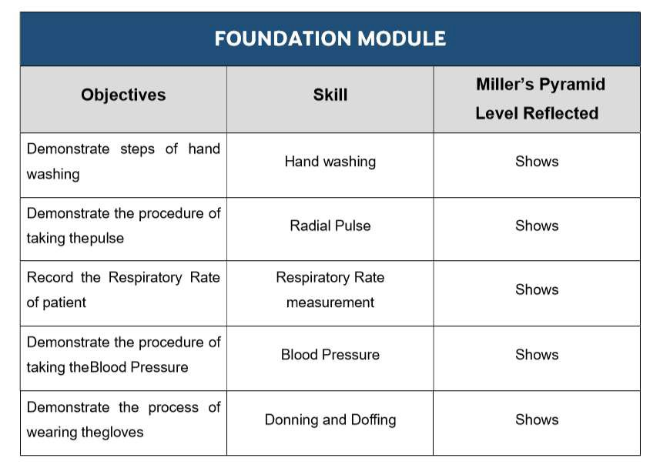**C-FRC for Foundation-1Module**



41

# Introduction of Hematopoietic and Lymphoid Module

Welcome to the Hematopoietic and Lymphoid Module, a vital component of your medical education. In this module, we will explore the formation and function of blood cells, focusing on red blood cells (erythrocytes), platelets, and white blood cells (leukocytes). First, we will delve into erythrocytes, which transport oxygen throughout the body. Understanding their production and regulation is essential for comprehending oxygen delivery and anemia.

Next, we'll examine platelets, crucial for blood clotting and wound healing. We'll explore their role in preventing excessive bleeding and their involvement in thrombotic disorders.

Then, we'll explore leukocytes, the body's immune defenders. From granulocytes to lymphocytes, we'll study their development, functions, and their roles in infection control and immunesurveillance.

Throughout, we'll highlight the interconnectedness between hematopoiesis and the lymphoid system. This includes understanding the structures and functions of lymphoid organs and their roles in generating immune responses.

By mastering these concepts, you'll gain a solid foundation for diagnosing and treating hematologic and immunologic disorders, preparing you for the challenges of clinical practice. Welcome to the intriguing world of hematopoiesis and lymphopoiesis

# Module Rationale

"Blood is Life". Unlike any other organ, components of blood and immunity reflect/reveal disease processes in other organs as well. Therefore, studying blood is like opening a book to all aspects of medicine. Hence, this module has been designed to enable students to have a basic understanding about the normal structure, function and biochemistry of blood, immune and Lymphatic systems. Not only that, but students would also learn, when normal physiology and composition of blood and immune system is disturbed, what disorders result in our community. Emphasis has been given to incorporate deranged laboratory findings into the clinical problem solving.

# Module Outcomes

* Explain the function of all the organs / structures involved in this system and the mechanisms controlling them. (Spleen, lymph nodes, thymus, bone marrow, RBC’s, WBCs and platelets
* Explain the etiology and pathogenesis of common blood & lymphatic diseases, particularly those of importance in Pakistan.
* Explain the rationale for the use of common therapeutic agents for the diseases related to
* Blood and immunity.
* Describe the role of immunity in the body
* Discuss the working & uses of laboratory instruments in diagnostic lab visit
* Relate red cell indices with health and disease
* Recognize ABO/RH blood groupings ystem
* Describe the role of Reticuloendothelial system in the body
* Describe the events of hemostasis
* Extrapolate the biochemical aspects of plasma proteins
* Discuss the pharmacological treatment of iron deficiency anemia
* Discuss Blood composition and function
* Discuss the role of liver in hemolyticanemia
* Practice history taking of a patient presented with blooddisorders
* **Thorax**

# Learning Objectives

## Knowledge

|  |  |  |
| --- | --- | --- |
| **Topic** | **Sub Topic** | **Learning objectives** |
| **Gross Anatomy** | Hematopoietic  & Lymphoid Tissue | * Identify and describe the components of the Hematopoietic & Lymphoid Tissue and theirfunction * Location, coverings, relations ofSpleen * Origin, course branches and distribution of Splenicartery * Venous drainage of Spleen, Portal vein Formation, tributaries, and area of drainage. * Location and relations of Thymus. Age related changes inThymus |
| **Embryology & Post-Natal Development** | Developmental Anatomy of Spleen | * Intrauterine Development ofspleen |

* **Physiology**

|  |  |  |
| --- | --- | --- |
| **Topic** | **Sub Topic** | **Learning objectives** |
| **Medical Physiology** | Anemia | * Define anemia and explain anemia on the basis of morphology andcause * Discuss the effects of anemia on thebody |
| Polycythemia | * Definepolycythemia * Explain types ofpolycythemias * Discuss the effects of polycythemia on the body |
| Hemostasis | * Definehemostasis * Describe the mechanisms by which hemostasis issecured |

|  |  |  |
| --- | --- | --- |
|  | Platelets | * Discuss the characteristics and functions of platelets * Explain the mechanism of formationof   plateletplug |
| Coagulation factors | * Enlist the clotting factors inblood * Explain the conversion of Prothrombin to Thrombin & formation of FibrinFibers * Explain the Intrinsic & extrinsic clotting pathway. * Name & explain the mechanism of anticoagulants used inlaboratory. * Explain the factors that prevent intravascularcoagulation * Explain the role of Calcium ions in Intrinsic and Extrinsicpathways * Enlist the vitamin K dependentclotting factors * Explain the prothrombin time, INR, and its clinicalsignificance. |
| Coagulation disorders | * Enlist and explain the conditions that cause excessivebleeding * Definethrombocytopenia * Enlist the causes and consequences of Thrombocytopenia |

|  |  |  |
| --- | --- | --- |
|  | Immunity | * Defineimmunity * Classifyimmunity * Explain humoralimmunity * Explain innateimmunity. * Elaborate cell mediatedimmunity. * Describe the structure of antigen and immunoglobulin * Describe the role of Helper T-cells in cell mediated immunity * Enlist the types of Immunoglobulinsalong with theirfunctions * Explain the role of memory cells in enhancing * antibody response (secondaryresponse) * Describe the mechanism of action of antibodies * Elaborate the complementsystem. |
| Tolerance | * Elaborate Immunetolerance * Explain the process of clone selection during T cellprocessing * Discuss the failure of tolerancemechanism |
| Immunization | * Discussimmunization. * Define passiveImmunity * Explain features and physiological basis of delayed reactionallergy. * Explain features and physiological basis of Atopic Allergy * Explain features and physiological basisof   Anaphylaxis, urticarial and Hay fever. |
| Blood group Incompatibility | * Discuss the pathophysiology, features and treatment of ABO and RHincompatibility * Enlist the changes that take place inthe   stored Blood |
| Blood mismatch Transfusion reactions | * Discuss the features and complications of mismatched blood transfusionreaction * Elaborate the Transplantation of Tissues andOrgans |

|  |  |  |
| --- | --- | --- |
|  | Transplantation of tissues | * Explain the process of tissuetyping * Explain prevention of Graft Rejection by suppressing immunesystem |

|  |  |  |
| --- | --- | --- |
| **Topic** | **Sub Topic** | **Learning objectives** |
| **Medical Biochemistry** | Hemoglobin and its types/ RBCs | * Explain the steps of synthesis ofhemoglobin and interpret Porphyrias on basis of sign symptoms anddata. * Discuss the biochemical role and types of hemoglobin   1. Differentiate Hemoglobin andmyoglobin   2. Explain oxygen dissociation curve of hemoglobin and myoglobin and factors regulatingthem   3. Interpret Carbon monoxide CO toxicityon basis of sign andsymptoms   4. Explain the role ofBisphosphoglycerate (2,3 BPG) in fetalcirculation |
| Hemoglobinopathies/ RBCs/ Homeostasis | * Discuss haemoglobinopathies and their biochemical and genetic basis with special emphasis on sickle cell anemia, Thalassemia andmethemoglobinemia * Discuss the following types of anemia on the basis of signs and symptoms and laboratory data:   1. Hypochromicmicrocytic   2. Normochromicmicrocytic   3. Normochromicnormocytic   4. Macrocytic(megaloblastic) |

* **Medical Biochemistry**

|  |  |  |
| --- | --- | --- |
|  | Iron Metabolism/ RBCs | * Explain the iron metabolism with mechanism of absorption and factors affectingit.   1. Interpret Iron deficiency anemia on basis of given data and microscopicfindings   2. Interpret folic acid and cobalamin in relation to anemias on given data and microscopicfindings   3. Discuss biochemical role ofpyridoxine   and vitamin C in microcytic anemia |
| Heme Degradation/ RBCs | * Discuss the degradation of heme in macrophages of reticuloendothelialsystem   1. Describe the formation of bile pigments, their types and transport   2. Discuss the fate ofbilirubin |
| Hyperbilirubinemias / RBCs/ Blood Groups | * Discuss hyperbilirubinemias and their biochemicalbasis   1. Differentiate types of jaundice on basis of sign/symptoms anddata   2. Evaluate the genetic basis of jaundice on the basis of labinvestigations |
| Plasma Proteins/ Homeostasis | * Classify and Explain the biomedical importance of each class of plasmaproteins |
| Immunoglobulins/ WBCs/ Immunity | * Explain the structure and biochemical role of immunoglobulins   1. Describe the production, structure and functions of B cells, plasma cells, and antibodies (IgA, IgD, IgE, IgG, andIgM).   2. Discuss the functions of the cytokines (ILs, TNFs, IFs, PDGF, andPAF).   3. Interpret multiple myeloma on basisof   given data |
| Genetics | * Explain and interpret pedigree of single gene defect i.e. sickle cell anemia (Autosomal recessive) and Beta Thalassemia ( x linked recessive) |

49

## Pathophysiology and Pharmacotherapeutics

|  |  |  |
| --- | --- | --- |
| **Topic** | **Sub Topic** | **Learning objectives** |
| **Pharmacology & Therapeutic** | Anemia | * Describe the oral and parenteral iron preparations including their pharmacokinetics, uses, adverseeffects * Vitamin B12 preparations,Iron   Antidotes |
| **Pathology** | Blood Cells, Platelets and Blood Group | * Should know the terms: Hematopoietic growth factors, their name, mechanism of actions , uses and adverseeffects * Define and classify anemias accordingto   underlying mechanism and MCV/MCH |
| * Discuss the causes and investigations of iron deficiency anemia and megaloblasticanemia * Classify the benign and malignant disorders ofWBCs * Discuss the causes leading to reactive leukocytosis * Interpretation of anemias on the basis of peripheral blood smear and bone marrow findings * Classify bleedingdisorders * Discuss first line laboratory investigations for bleedingdisorders * Describe the basic concept of blood grouping and acute hemolytictransfusion reaction |

* **Aging**

|  |  |  |
| --- | --- | --- |
| **Topic** | **Sub Topic** | **Learning objectives** |
| **Aging** | Platelet Rich Plasma Therapy | * Discuss the role of platelets in PRPtreatment in old age (for skin, hairs and joints) |
| Glutathione | * Explain the role of glutathione inskin |

|  |  |  |
| --- | --- | --- |
|  |  | whitening |

* **Disease Prevention & impact**

|  |  |  |
| --- | --- | --- |
| **Topic** | **Sub Topic** | **Learning objectives** |
| **Community Medicine and Public Health** | Anemia | * Describe the nutritional aspects of iron deficiency * anemia and psychological aspects ofdiseases |
| Communicable diseases | * Enlist most common blood borne diseases in Pakistan * Describe the routes of spread of bloodborne   diseases |
| Genetic diseases | * Genetic counseling ofparents |
| **Behavioral Sciences** | Counselling, informational care | * Psychological Counselling of patients and theirfamilies |
| Personal, Psychosocial and vocational issues | * Identify and deal with the various psychosocial aspects of Hematopoietic System disorders (such as Sickle Cell Disease, Hemophilia, and Conditions of the Blood) on Individual, Family andSociety. |

51

* **Practical’s**

# Skills

|  |  |  |
| --- | --- | --- |
| **Topic** | **Sub Topic** | **Learning objectives** |
| **Histology** | Histological features of lymph node, spleen  &thymus | * Light microscopic structure ofSpleen,   Thymus, Lymph nodes, tonsils and MALT including Appendix. |
| **Biochemistry** | Jaundice & Anemias/ RBCs/ Homeostasis | * Interpret jaundice on the basis of data perform estimation ofbilirubin |
| **Physiology** | Bleeding/Clotting time | * Interpret the Red Blood Cell Count, Hemoglobin concentration, Hematocrit and RBC Indices by Automated CellCounter * Interpret the Total Leucocyte Count, Differential Leucocyte Count PlateletCount   by Automated Cell Counter. |
| Jaundice & Anemias/  RBCs/ Homeostasis | * Determine BleedingTime. * Determine ClottingTime. |

* + - 1. 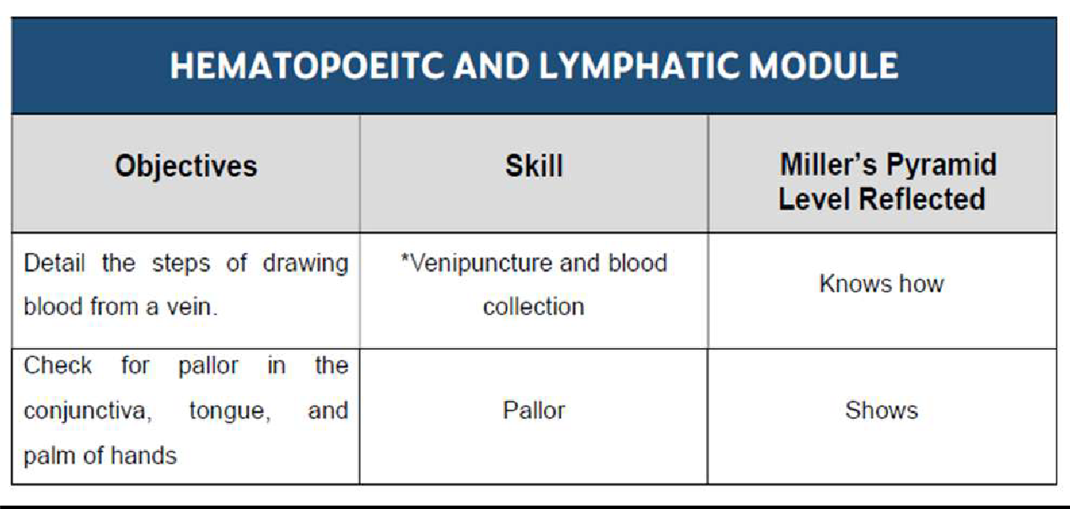**C-FRC for Hematopoietic and LymphaticModule**
* **PERL’s for Block-I**

# Attitude

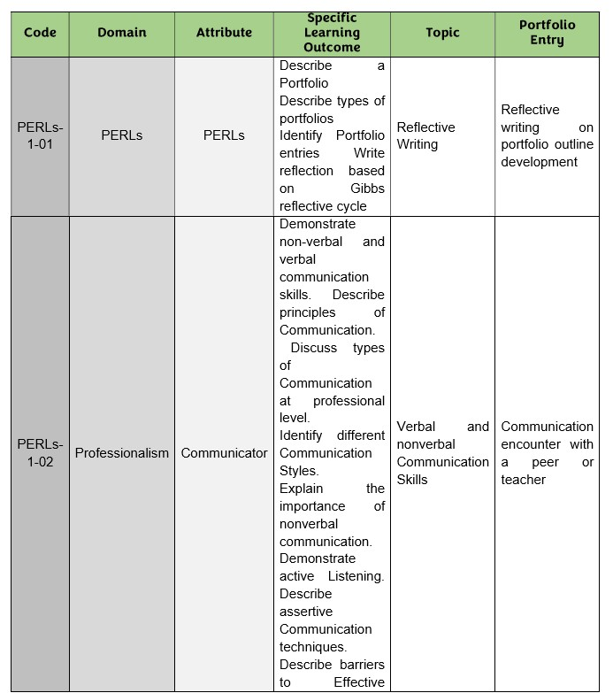

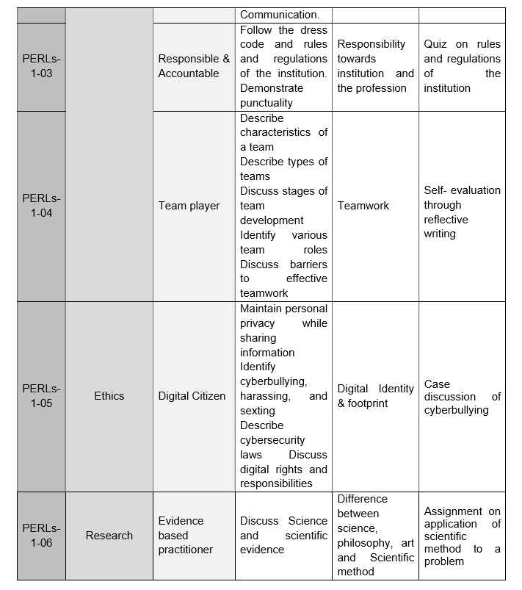

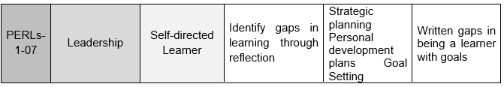



**ASSESSMENT POLCIY AND TOS OF UHS**

* 1. **Teaching & Learning Methodologies**

### Interactive Lectures

Interactive lecturing involves an increased interchange between teachers, students and the lecture content. The use of interactive lectures can promote active learning, heighten attention and motivation, give feedback to the teacher and the student, and increase satisfaction for both.

### Small group discussions

Small-group discussion is a student-centered methodology that allows students to actively involve and be partners in the teaching-learning process. Students interact with peers and instructors, discussing, and sharing ideas. They develop the ability to build consensus in a group.

### Practical’s

Hands-on performance of skills in laboratory

### Clinical Skills Session

* Clinical skills are abilities health care professionals use when assessing, diagnosing and caring for patients. Clinical skills also describe applied medical knowledge, such as assessingbloodwork.

### Case based Learning

Case-based learning is a student-centered learning approach where students read and discuss complex situations and apply their knowledge to each situation. Students typically examine the case together as a team and address the problems within the realistic scenario to develop a reasonableconclusion.

### Problem Based Learning

Problem-based learning (PBL) is a student-centered approach in which students learn about a subject by working in groups to solve an open-ended problem. This problem is what drives the motivation and the learning.

### Self-directed learning

Self-directed learning is an instructional strategy where the students with guidance from the teacher decide what and how they will learn. It can be done individually or with group, learning, but the overall concept is that students take honor ship of theirlearning

# Assessment Methodologies

## Theory

* **MCQ’s**

A multiple-choice question (MCQ) is composed of two parts: a stem that identifies the question or problem, and a set of alternatives or possible answers that contain a key that is the best answer to the question, and a number of distractors that are plausible but incorrect answers to the question.

## SEQ’s

It is a type of assessment tool in which a question on a topic is given in test or examination requiring a written analysis and explanation usually of a specified length.

## Practical

* **OSPE**

“Objectively Structured Practical Examination.”, as a tool for the assessment of practical skills of undergraduate Medical Students.

## OSCE

OSCE stands for “Objectively Structured Clinical Examination.” OSCEs are very helpful in medical education because they allow a student to practice and demonstrate clinical skills in a standardized medical scenario.

## OSVE

OSVE stands for “Objectively Structured Viva Examination”. In the viva you have to answer questions and engage with your examiners.

58

## Statutes

* 1. **Assessment Policy (UHS)**

1. The first professional MBBS shall be held at the end of first year MBBS whereas, the second Professional MBBS Examination shall be held at the end of the secondyear.
2. Every candidate shall be required to study contents of Anatomy (including Histology), Physiology, Biochemistry, Behavioral Sciences, Community Medicine & Public Health, Pathology, Pharmacology & Therapeutics, Islamic Studies/Ethics and Pakistan Studies, Clinical skills and Professionalism, Ethics, Research and Leadership. The teaching and assessment shall be done in three modularblocks.
3. There will be three papers in the first professional examination, and four papers in the second professionalexamination

### First Professional Exam:

* 1. Paper 1 will be based on contents of Block1;
  2. Paper 2 will be based on contents of Block2;
  3. Paper 3 will be based on contents of Block3;

### Second Professional Exam:

1. Paper 1 will be based on contents of Block4;
2. Paper 2 will be based on contents of Block5;
3. Paper 3 will be based on contents of Block6;
4. Paper 4 will be based on contents of Islamic Studies/Civics and PakistanStudies;
5. Each paper will comprise of two components ‘Written’ and‘Oral/Practical/Clinical’

examinations.

1. The ‘Written’ and ‘Oral/Practical/Clinical’ examinations in each paper will carry 150 marks each, making the total marks of 300 for each paper of papers 1, 2 and 3 (inclusive of internalAssessment).
2. Total marks for the First and Second Professional Examination shall be 900, each. Marks of Islamic Studies/Civics and Pakistan Studies shall not be counted towards total marks of any professional examination and determination of positions or merit of the candidate. However, the candidates shall have to take the examination in the subject in their Second Professional MBBS Examination. Those failing the subject in both annual & supplementary examinations, while passing all the other subjects of Second Professional Examination shall be promoted to the 3rdyear MBBS, however they will be allowed two more attempts to clear the subject with professional Examination of the next session, failing which they shall be detained in the 3rdProfessionalMBBS.
3. Major content areas of the first two professional years shall befrom:
4. Anatomy includingapplied/clinical/Anatomy
5. Physiology includingapplied/clinical/Physiology
6. Biochemistry including applied/clinical/Biochemistry
7. The Applied/Clinical content for the Anatomy, Physiology and Biochemistry shall be based on clinicalcorrelations.

59

1. Integrated clinical content areas for the both years include Behavioral Sciences, Community Medicine & Public Health, Pathology, Pharmacology & Therapeutics, Clinical Foundation- 1& II and PERLs- 1 &II.

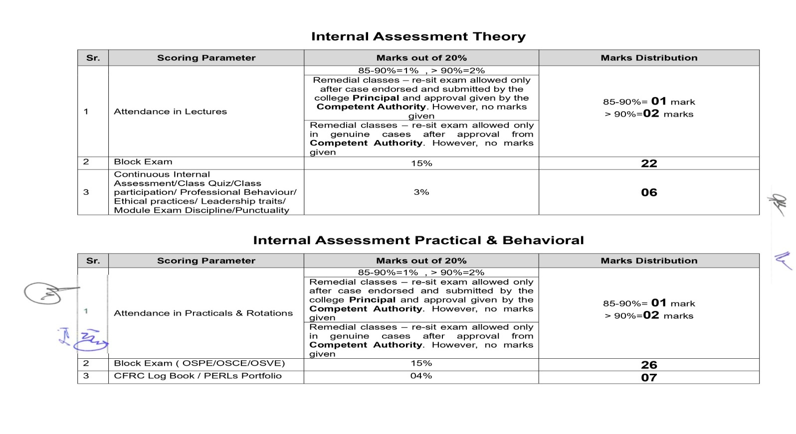

### Written Examination

1. The written component of Papers 1, 2, and 3 will consist of ‘One-best-type’ Multiple Choice Questions (MCQ) and Structured Essay Questions (SEQ) in a ratio of 70:30%.
2. Each MCQ will have five options (one best response and four distractors) and will carry one (01) mark.
3. There will be no negative marking.
4. There will be no sections within an SEQ, and it will be a structures question with five (05) marks each.
5. SEQ’s will only be based on the major content areas of theyear.
6. There will be total of 85 MCQs and 07 SEQs in every written paper in Papers 1, 2 and 3.
7. The duration of each written paper will be 180 minutes (03hours).
8. The MCQ section will be 110 minutes duration and the SEQ section 70minutes.

### Oral/Practical/Clinical Examination

1. The Oral/Practical/Clinical examination of each Paper 1, 2, and 3 will consist of a total of twelve (12) OSPE/OSCE/OSVE stations in each Oral/Practical/Clinical examination.
2. There will be seven (07) Observed OSPE (Objective Structured Practical Examination) stations from major subject areas. Each OSPE station will have the Practical component and an evaluation of the underlying principle relevant to that practical with a component of applied knowledge.
3. There will be two (02) Observed OSCE (Objective Structured Clinical Examination) stations, 01 from C-FRC1 and PERLs-1 in each Oral/Practical/Clinical examination.
4. There will be three (03) Observed Interactive OSVE (Objective structured Viva Examination) from major subject areas. Each OSVE station will have a structured Viva to assess a practical component along evaluation of the underlying principle relevant to that practical with a component of applied/practical knowledge and related clinical application.
5. Each OSPE/OSCE will carry eight (08) marks.
6. Each OSVE station will carry 16marks
7. The duration of each Oral/Practical/Clinical examination will be 120 minutes (2 hours).
8. Time for each OSPE, OSCE and OSVE station will be eight (08)minutes.
9. Every candidate shall take the examination in the following Blocks (Modules) in First & Second Professional MBBS Examination:

### Year 1

1. Block 1 (Foundation-I + Hematopoietic &Lymphatic) Marks 300
2. Block 2 (Musculoskeletal &Locomotion-1) Marks 300
3. Block 3 (Cardiovascular-lRespiratory-1)Marks 300

**Year 2**

|  |  |
| --- | --- |
| a. Block 4 (Gastrointestinal Tract & Nutrition- Renal-1) Marks | 300 |
| b. Block 5 (Endocrinology & Reproduction Head & Neck, Special Senses) | 300 |
| Marks |  |
| c. Block 6 (Neurosciences-1+ Inflammation) Marks | 300 |
| d. Islamic Studies Civics Pakistan Studies Marks | 100 |

1. **Block 1 (Foundation- Hematopoietic and Lymphatic)**

The examination in Block 1 shall be as follows:

* 1. One written paper of 120 marks having two parts
     1. Part I shall have eighty-five Multiple Choice Questions (MCQs) of total 85 marks (01 mark for each MCQ) and the time allotted shall be 110 minutes. There will be no negative marking.
     2. Part II shall have seven Structured Essay Questions (SEQs) of total 35 marks (05 marks for each SEQ) and the time allotted shall be 70minutes.
  2. Oral Practical/Clinical examination shall have 120 marks intotal.
  3. The continuous internal assessment through Block Examination conducted by the collegeofenrollmentshallcarry60marks,e20%ofthetotalallocatedmarks

(300) for the block The score will be equality distributed to the Written and Oral/Practical Clinical Examinations

### Block 2 (Musculoskeletal &Locomotion-1)

1. One written paper of 120 marks having two parts
   1. Part I shall have eighty-five Multiple Choice Questions (MCQs) of total 85 marks (01 mark for each MCQ) and the time allotted shall be 110 minutes. There will be no negative marking.
   2. Part II shall have seven Structured Essay Questions (SEQs) of total 35 marks (05 marks for each SEQ) and the time allotted shall be 70minutes
2. Oral Practical/Clinical examination shall have 120 marks in total.
3. The continuous internal assessment through Block Examination conducted by the collegeofenrollmentshallcarry60marks,e20%ofthetotalallocatedmarks

(300) for the block The score will be equality distributed to the Written and Oral/Practical Clinical Examinations

### Block 3 (Cardiovascular-l +Respiratory-1)

* 1. One written paper of 120 marks having two parts
     1. Part I shall have eighty-five Multiple Choice Questions (MCQs) of total 85 marks (01 mark for each MCQ) and the time allotted shall be 110 minutes. There will be no negative marking.
     2. Part II shall have seven Structured Essay Questions (SEQs) of total 35 marks (05 marks for each SEQ) and the time allotted shall be 70minutes.
  2. Oral Practical/Clinical examination shall have 120 marks in total.
  3. The continuous internal assessment through Block Examination conducted by the collegeofenrollmentshallcarry60marks,e20%ofthetotalallocatedmarks

(300) for the block the score will be equality distributed to the Written and Oral/Practical Clinical Examinations.

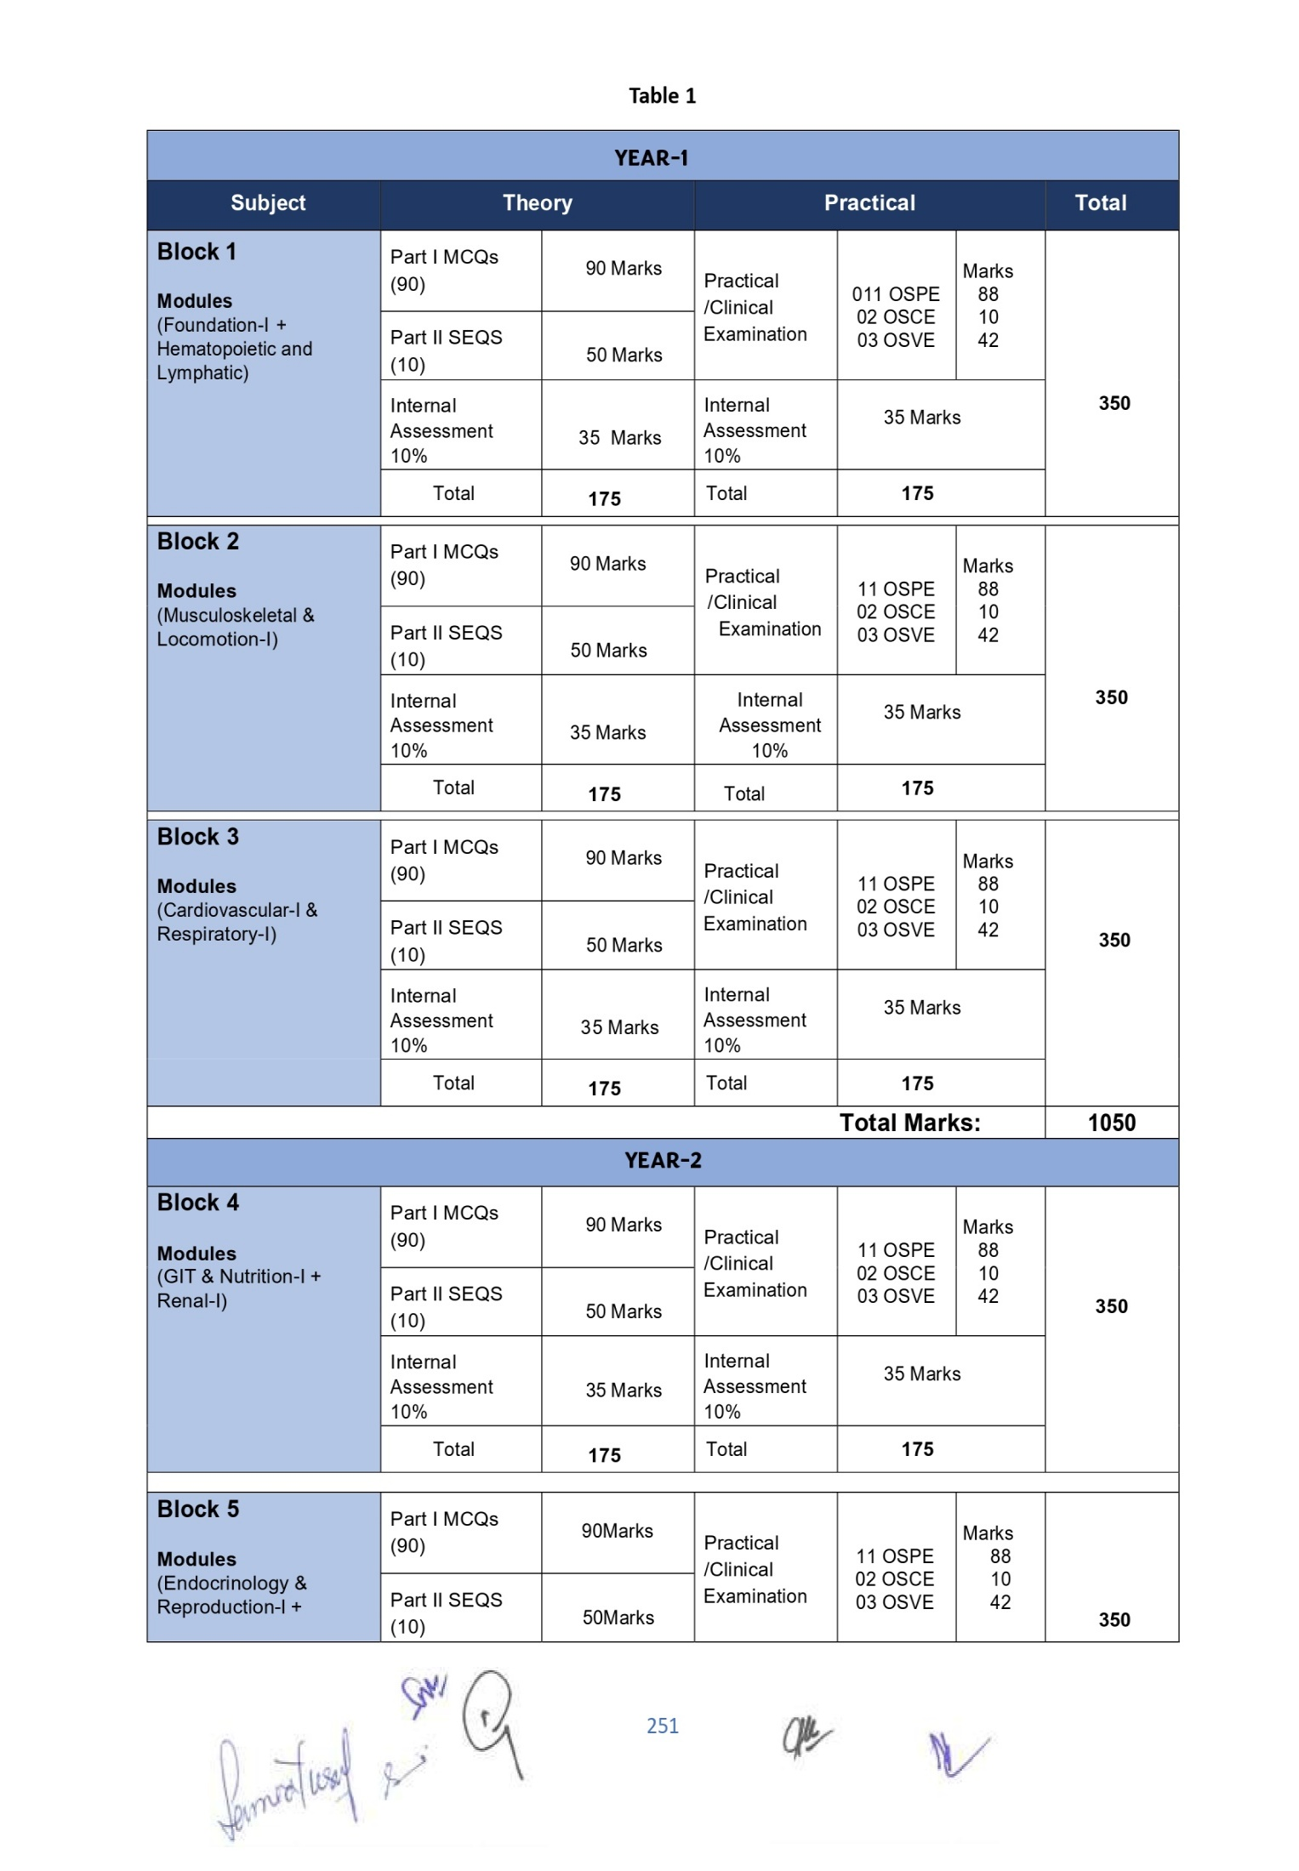

### No grace marks shall be allowed in any examination or practical under any guise or name.

1. At least 25% MCQ & 25% SEQ shall be based on applied/case/clinical scenarios to assess high order thinking in the papers set for the students of First and Second Professional MBBS Examination.

63

# 11. Exam Regulations by UHS

1. Professional examination shall be open to any student who:
   1. Has been enrolled/ registered and completed one academic year preceding the concerned professional examination in a constituent/affiliated College of the University.
   2. Has his/her name submitted to the Controller of Examinations, for the purpose of examination, by the Principal of the college in which he/she is enrolled & is eligible as per all pre-requisites of the examination
   3. Has his/her marks of internal assessment in all the Blocks sent to the Controller Examinations by the Principal of the college along with the admission forms.
   4. Produces the following certificates duly verified by the Principal of his/ her College:
      1. Of good character;
      2. Of having attended not less than (85%) of the full course of lectures delivered and practical conducted in the particular academic session in each Block, as well as in aggregate.
      3. Certificate of having appeared at the Block Examinations conducted by the college of enrolment with at least 50% cumulative percentage in aggregate of blocks 1, 2 and 3 for the first year and blocks 4, 5 and 6 for the second year.
      4. Candidates falling short of lectures or practical shall not be admitted to the examination but may be permitted to appear at the supplementary examination if they make up the deficiency up to the commencement of the next examination by remaining on the rolls of a college as regular student, subject to fulfillment of all other mandatory requirements to appear at the examination.
2. The minimum number of marks required to pass this examination for each paper shall be fifty percent (50%) in Written and fifty percent (50%) in the Oral/Practical/Clinical examinations and fifty percent (50%) in aggregate, independently and concomitantly at one and the same time.
3. Candidates who secure eighty five percent (85%) or above marks in any of the papers shall be declared to have passed **“with distinction”** in that Block subject to having at least 80 % marks in the Written component of that paper, concomitantly. However, no candidate shall be declared to have passed “with distinction” in any paper, who does not pass in all the papers of the First Professional Examination as a whole at one and the same time.
4. A candidate failing in one or more paper of the annual examination shall be provisionally allowed to join second professional class till the commencement of supplementary examinations. Under no circumstances, a candidate shall be promoted to the second professional class till he/she has previously passed all the papers in the First Professional MBBS Examination.

64

1. If a student appears in the supplementary examination for the first time as he/she did not appear in the annual examination because of any reason and fails in any paper in the Supplementary Examination, he/she will be detained in the same class and will not be promoted to the next class.
2. Any student who fails to clear First Professional Examination in four consecutive attempts, inclusive of both availed as well as un-availed, after becoming eligible for the examination, and has been expelled on that account shall not be eligible for continuation of studies and shall not be eligible for fresh admission as a fresh candidate in either MBBS or BDS. (Ref. UHS Circulars/137-20/2750 dated23-11-2020).
3. The colleges may arrange remedial classes and one re-sit for black examination either with the subsequent block examination or before completion of the block, and before or during preparatory leave in case of the terminal block of the professional year, before issuance of the date sheet for the concerned professional examination, subject to the following condition:
4. At the completion of each block, the principals of the colleges shall submit a detailed report to the university, including cases of students with short attendance poor performance/absence in the block examination along with the reasons and evidence for the same, proposed schedule to remedial classes and re-sit examination.
5. Competent Authority UHS will have the cause and the submitted evidence evaluated and documented, before permitting the colleges to arrange remedial classes and re-sit examination at the concerned block. No college is allowed to conduct remedial classes or re-sit examination without prior approval of the competent authority
6. The students can appear in re-sit of a block examination, along with the subsequent block, and before or during preparatory leave for the terminal black of the professional year, once the requirement of attendance is met with However conduct of remedial classes shall be permitted only in the cases of students, who shall have attended at least 50% of total attendance of the concerned block in the first instance
7. The valid reasons for short attendance in a block or absence from a block examination may include major illness/accident/surgery of the student or death of an immediate relative/being afflicted by a natural calamity or disaster
8. The application for admission of each candidate for examination shall be submitted to the Controller of Examination, through the Principal of the College, in a prescribed format, as per notified schedule, accompanied by the prescribed fee.
9. The marks of internal assessment and attendance shall be submitted to Controller of Examinations three times, within two weeks of completion of each block examination
10. At the end of each block, the colleges are required to submit question papers and keys for the block examination, internal assessment marks and attendance record to the Department of Examinations UHS. Further, parent-teacher meetings shall be arranged by thecollegesaftereveryblockexaminationtosharefeedbackontheprogressofstudents

65

with their parents, Minutes of parent teacher meetings shall be submitted to the Department of Medical Education UHS.

1. ll is emphasized that fresh internal assessment or a revision of assessment for supplementary examination shall not be permissible. However, a revised internal assessment for the detained students can be submitted. The internal assessment award in a particular year will not be decreased subsequently detrimental to the detainee candidate. A proper record of the continuous internal assessment shall be maintained by the concerned departments in the colleges.
2. The candidates shall pay their fee through the Principals of their respective colleges who shall forward a bank draft / pay order / crossed cheque in favor of Treasure, university of Health Sciences Lahore, along with their Admission Forms.
3. Only one annual and one supplementary of First and Second Professional MBBS Examinations shall be allowed in a particular academic session. In exceptional situations i.e., national calamities, war or loss of solved answer books in case of accident, special examination may be arranged after having observed due process of law. This will require permission of relevant authorities, i.e., Syndicate and Board of Governors.

66

# Examination Rules DGKMC

* Students must report to examination hall/ venue at least 30 minutes before the exam.
* Exam will start sharp at time.
* Late comers arriving at the examination hall more than 15 minutes after the start of the paper will not be allowed to enter the examination hall.
* All students should wear Lab coats before appearing in the exam.
* Students are not allowed to take into the examination hall textbooks, notes or manuscript of any kind.
* Students must bring the necessary stationary items for exam with them e.g. pen/pencil/eraser/ball point/sharpener etc.
* Mobile phones and gadgets are strictly prohibited in examination hall. If any student found with Mobile Phone (Silent/Switched off/on) he/she will not be allowed to continue the exam.

# Table of Specification (TOS)

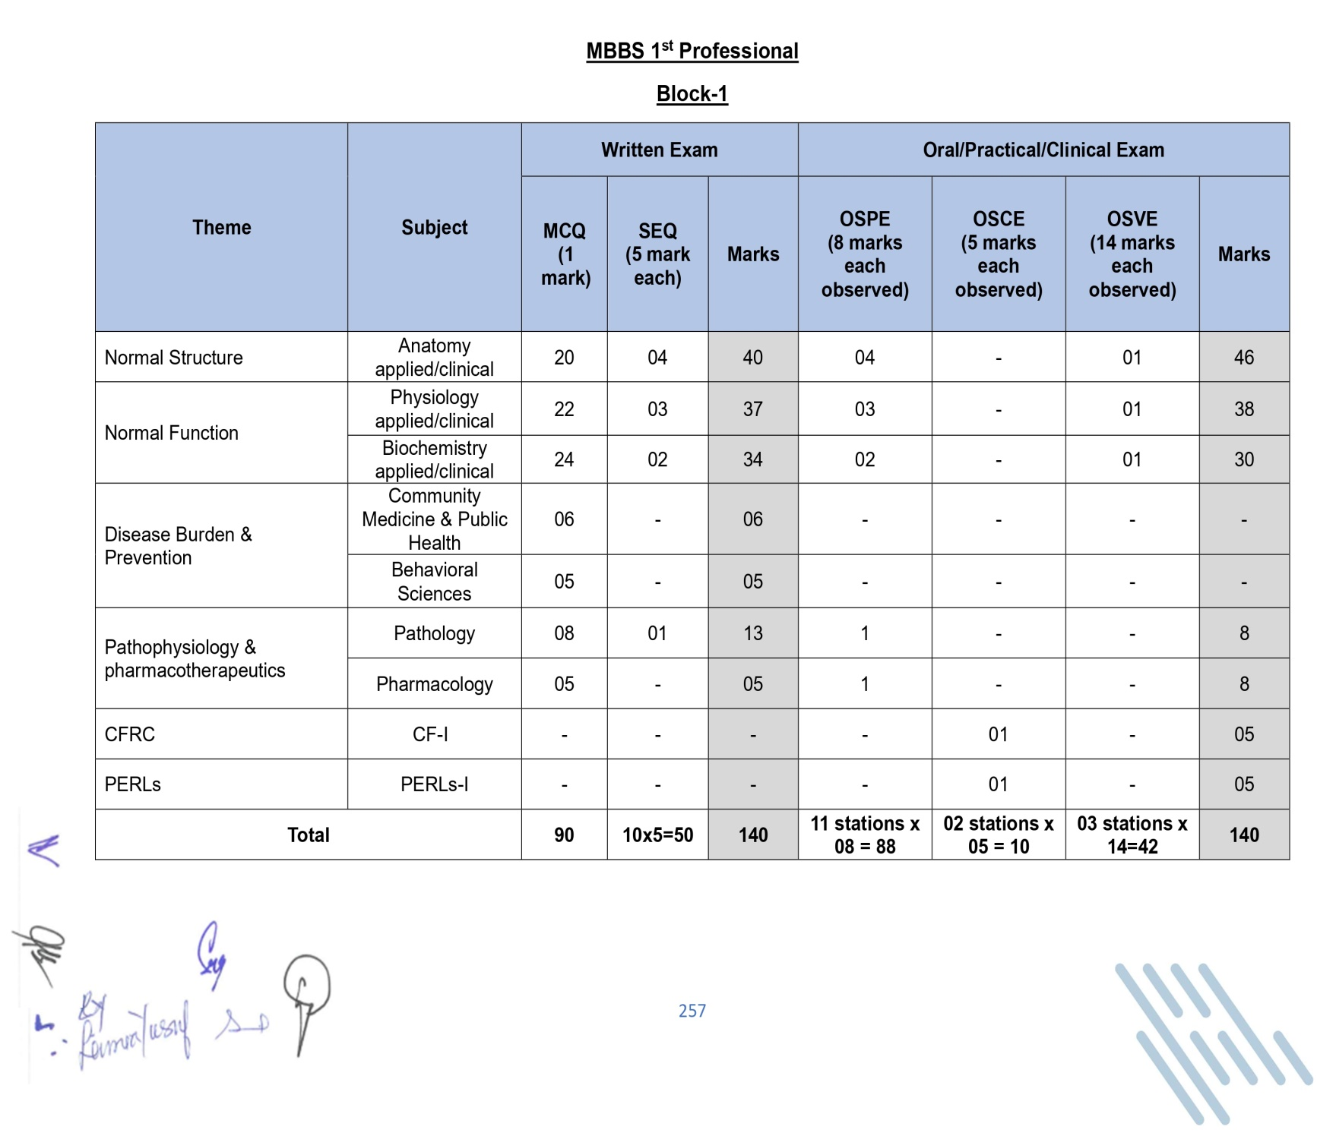

68

# Frame work of Block-1 Module Timetable 2025

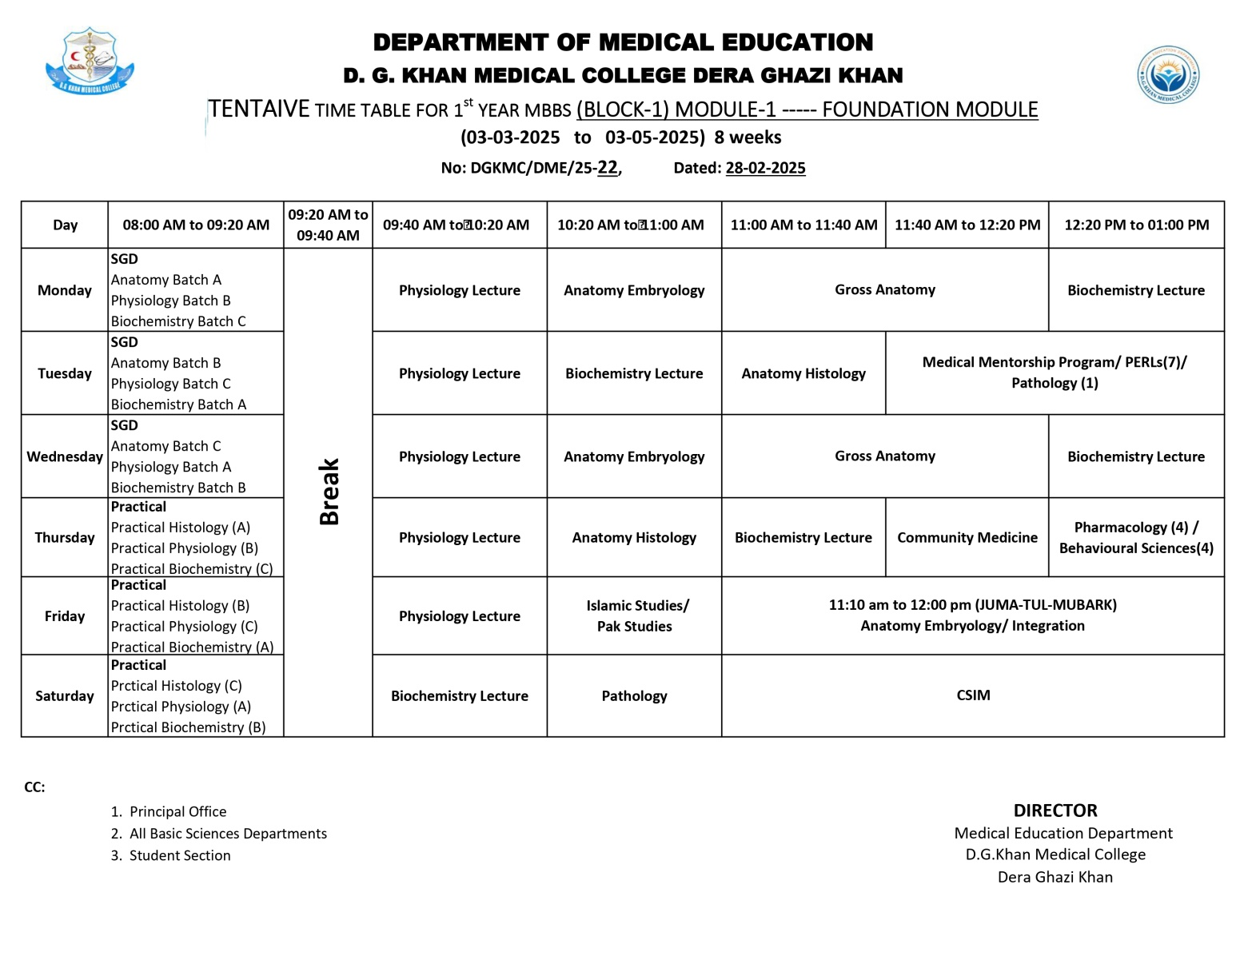

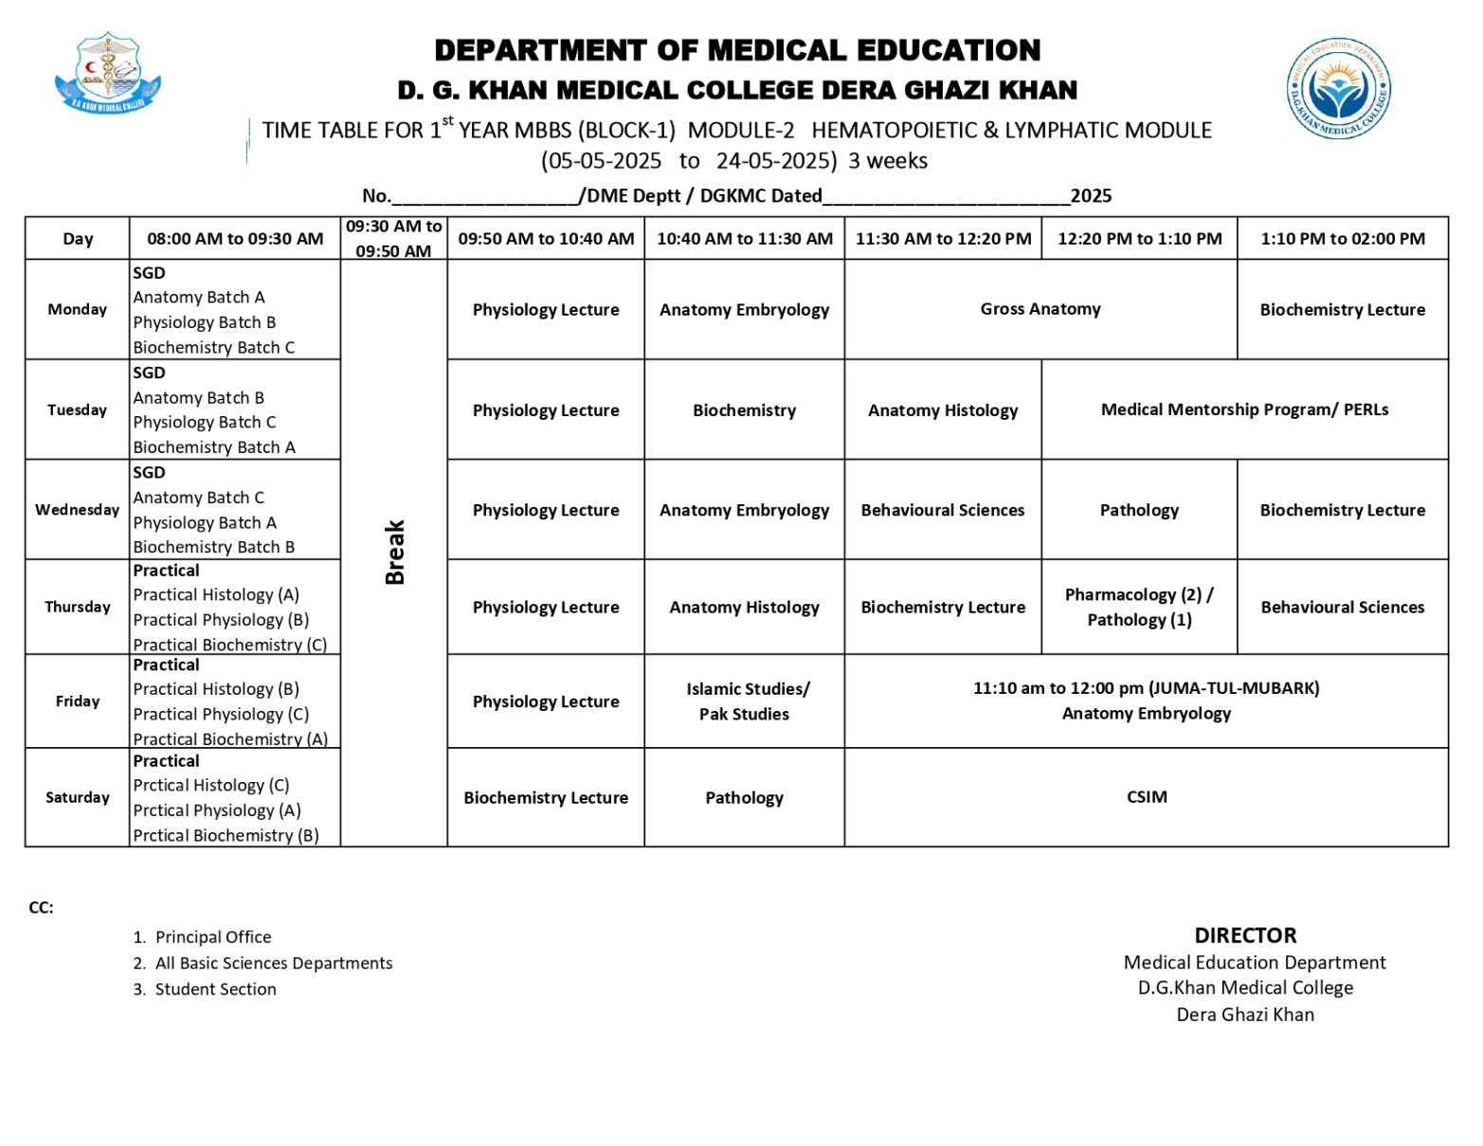

70

# Learning Resources

|  |  |
| --- | --- |
| Anatomy | * Snell’s Clinical Anatomy 10thed. * Langman’s Medical Embryology 12thed * Medical Histology by Laiq Hussain Siddiqui 8thed. * General Anatomy by Laiq Hussain Siddiqui 6thed. |
| Physiology | * Guyton AC and Hall JE. Textbook of MedicalPhysiology,   W.B. Saunders & Co. Philadelphia   * Essentials of Medical Physiology by MushtaqAhmad |
| Biochemistry | * Harpers illustrated Biochemistry 32nd edition. Rodwell.V.WMCGrawHillpublishers. * Lippincott illustrated Review 8th edition Kluwer.W. * Essentials of Medical Biochemistry vol 1&2 by Mushtaq Ahmed. |
| Community Medicine | * Parks TextBook of Preventive and Social Medicine, K. Park(Editor) * Public Health and Community Medicine IlyasAnsari(Editors) |
| Pharmacology | * Basic and clinical Pharmacology by Katzung.McGraw-Hill * Pharmacology by Champe and Harvey, Lippincott Williams & Wilkins |
| Pathology | * Vinary Kumar, Abul K. Abbas and Nelson Fausto Robbins and Cotran, Pathologic basis of disease. WBSaunders. * Richard Mitchall, Vinary Kumar, Abul K. Abbas and Nelson Fausto Robbinsand * Cotran, Pocket Companion to Pathologic basis of diseases. SaunderHarcourt. * Walter and Israel. GeneralPathology. * ChurchillLivingstone. |
| Medicine | * Davidson’s Principles and Practice ofMedicine |
| Surgery | * Bailey & Love Short Practice ofSurgery |
| Islamiyat | * Standard Islamiyat (compulsory) for B.A, B.Sc, MA, Msc, MBBS by Prof. M SharifIslahi * IlmiIslamiyat (compulsory) mforB.A, B.sc &equilent. |
| Behavioral Sciences | * Handbook of Behaioural Sciences by Prof. Mowadat H. Rana, 3rdEdition. * Medical and Psychosocial Aspects of Chronic illness and Disability Sixth Edition Donna R. Falvo, PHD Beverley E. Holland, PHD RN. |